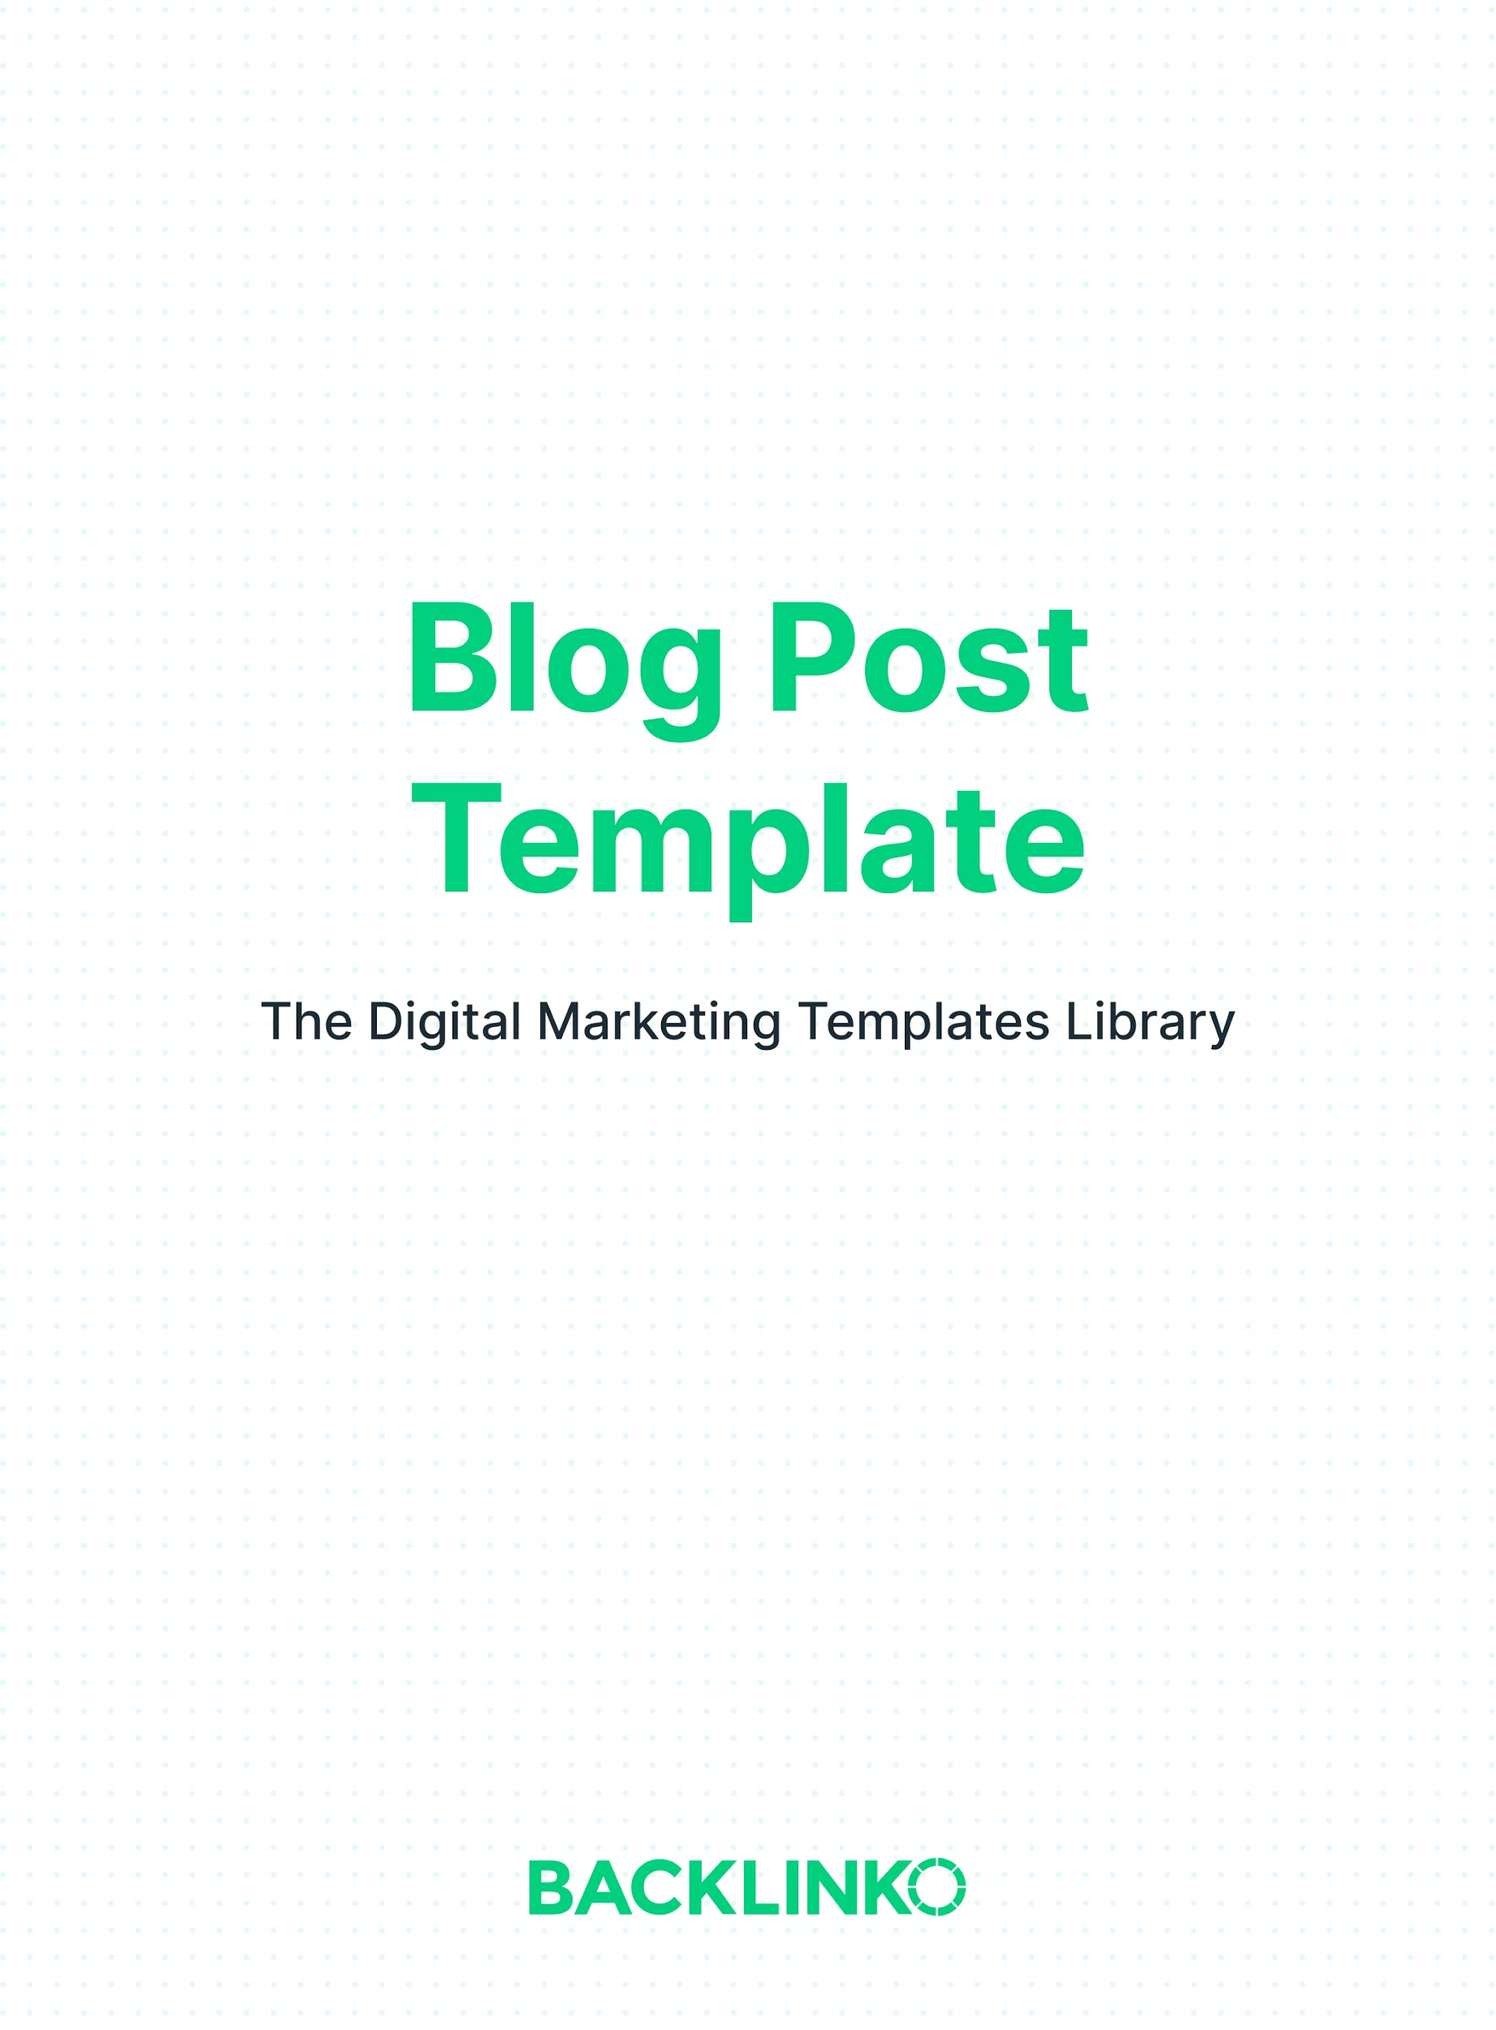

This document contains 3 different blog post templates:

- The Expanded List Post
- The Ultimate Guide
- The Product Showdown

In each of the following templates, replace the example text with your own.

The Expanded List Post
This is like a regular list post… but better.

With the Expanded List Post, you give LOTS of detail about each item on your list.

You can see this type of blog post in action in the Backlinko article 17 Actionable Content Marketing Tips For More Traffic

Title, with the specific number of items from the list, a specific benefit, and a timeframe:

17 Insanely Actionable Ways to Get More Blog Traffic Today

Introduce the problem and promise a solution:

I think you’ll agree with me when I say:

It’s REALLY hard to convert ice cold traffic into email subscribers.

Well, it turns out, you can dramatically increase your site’s email signups with a few simple website tweaks.

In fact, these same tweaks helped boost my site’s conversion rate by 189%.

List the items, including plenty of detail on each:

Tip #1: Get More Subscribers From Your Homepage

Why is your homepage so important to boost subscribers?

Because… [etc.]

This is what you do:

- Step A
- Step B
- Step C
- Step D

Tip 2: …

[etc.]

Conclusion, including a specific call-to-action:

What Do You Think?

Now it’s your turn:
Which traffic technique from this list was your favorite?
Was it how to get more subscribers from your homepage? Or how to maximize your social shares?

Or maybe you have a tip that I didn’t cover here.

Either way, leave a comment below to let me know.

The Ultimate Guide
The Ultimate Guide format is designed to cover EVERYTHING about a single topic. That makes them huge magnets for backlinks and social shares.

Ultimate Guides are both informative and actionable. But they aren’t arranged into chronological steps. (If you want to make a step-by-step guide, try a Detailed Case Study or Beginner’s Guide.)

You can see this type of blog post in action in the Backlinko article The Definitive Guide To SEO

Title, with an SEO keyword and positioning term like “complete”, “definitive” or “ultimate”:

Conversion Rate Optimization: The Definitive Guide

Introduction, including a big promise, why the topic is important, and transition that shows how your guide can help them master the topic:

This is the most comprehensive guide to CRO… ever. In this guide you’ll learn everything you need to know about turning your traffic into leads, sales and customers.

With traffic getting harder to come by, conversion rate optimization is one of the best channels to grow your business. In fact, 75% of small business owners cite CRO as an “important marketing channel”.

The question is: how can you get more conversions on your website? Well, that’s where this ultimate guide comes into play.

About The Author section, including why you wrote this guide, why people should listen to you, and who this guide is for:

About The Author

I’m John Smith.

I spent years trying to create an online business before I finally succeeded. It was one disaster after another.

Finally, I struck gold in 2014, launching my first successful product to a small email list of 1,429 people. Since then, this site has grown into a 7-figure business.

How?

By using the exact CRO techniques I’ll share with you in this post. So if you want to grow your conversions, keep reading and I’ll show you exactly how.

Chapters, each consisting of a short introduction, 4-5 tips, summary, and “bridge” to the next chapter.

Chapter 1: Getting Started With Conversion Rate Optimization

Once you’re getting a decent amount of traffic, the single biggest thing you can do to improve your results is to increase your conversion rate.

- Tip A
- Tip B
- Tip C
- Tip D
- Tip E

After you have the basics in place, it’s time to move on to the next step: Collecting good data.

Chapter 2: Collecting Good Data

[etc.]

Conclusion, including a summary and call-to-action:

Now It’s Your Turn

In this guide, we looked at everything there is to know about CRO. From setting up Google Analytics, to the best A/B testing tools, to designing effective tests and more.

Now it’s your turn: Which of these tips are you going to try first?

Leave a comment below to let me know.

The Product Showdown
The Product Showdown is a side-by-side comparison of two competing products.

This type of post provides a ton of value. That’s because it can save your reader countless hours (and dollars) on a product that may not work for them.

And if affiliate sales are part of your monetization strategy, this format is a natural fit.

You can see this type of blog post in action in the Backlinko article Ahrefs vs SEMrush: Which SEO Tool Should You Use?

Title, including the names of the two products and what they do:

Aweber Vs. Mailchimp: Two Email Marketing Platforms Compared

Introduction, including an overview with the product features you’ll be evaluating and a suggestion to read until the end:

In this post I’m going to personally review the two popular email marketing software products: Mailchimp and Aweber.

I dove deep into each platform to uncover the good, the bad (and the ugly).

Within each platform I evaluated:

- Cost/value
- Email deliverability
- Templates
- Ease of use
- Advanced features
- Autoresponders
- Customer support
- and more

So make sure to read this review until the end. That way you can make the best decision for you.

Product Overview, with an overview of each product, who you are, and a feature-by-feature comparison:

Product Overview

Before I get into the review itself, I want to quickly let you know some important info on each platform…

Because I started my WordPress blog on a shoestring budget, I went with Mailchimp’s free plan. Overall, I was pretty happy with it. But I quickly realized that the more advanced features only came with a paid Mailchimp account…

 | Aweber | MailChimp
Cost/Value |  | •
Email Deliverability | •
Templates |  | •
Ease of Use | •
Advanced Features | •
Autoresponders | •
Customer Support

Conclusion, with your recommendation:

Conclusion

Because it has a much more robust feature set, better deliverability, and support, I have to go with Aweber. If you’re on an absolute “zero budget” budget, then you might want to start with Mailchimp.

But if you have two pennies to rub together, I recommend going with Aweber. As you saw in this review, Aweber’s robust features are worth the slightly higher investment.

And that concludes this blog post template. I hope you enjoyed it! You can also check out our case study template here, as well as 20+ other marketing templates right here.

Brian Dean
Founder, Backlinko.com

