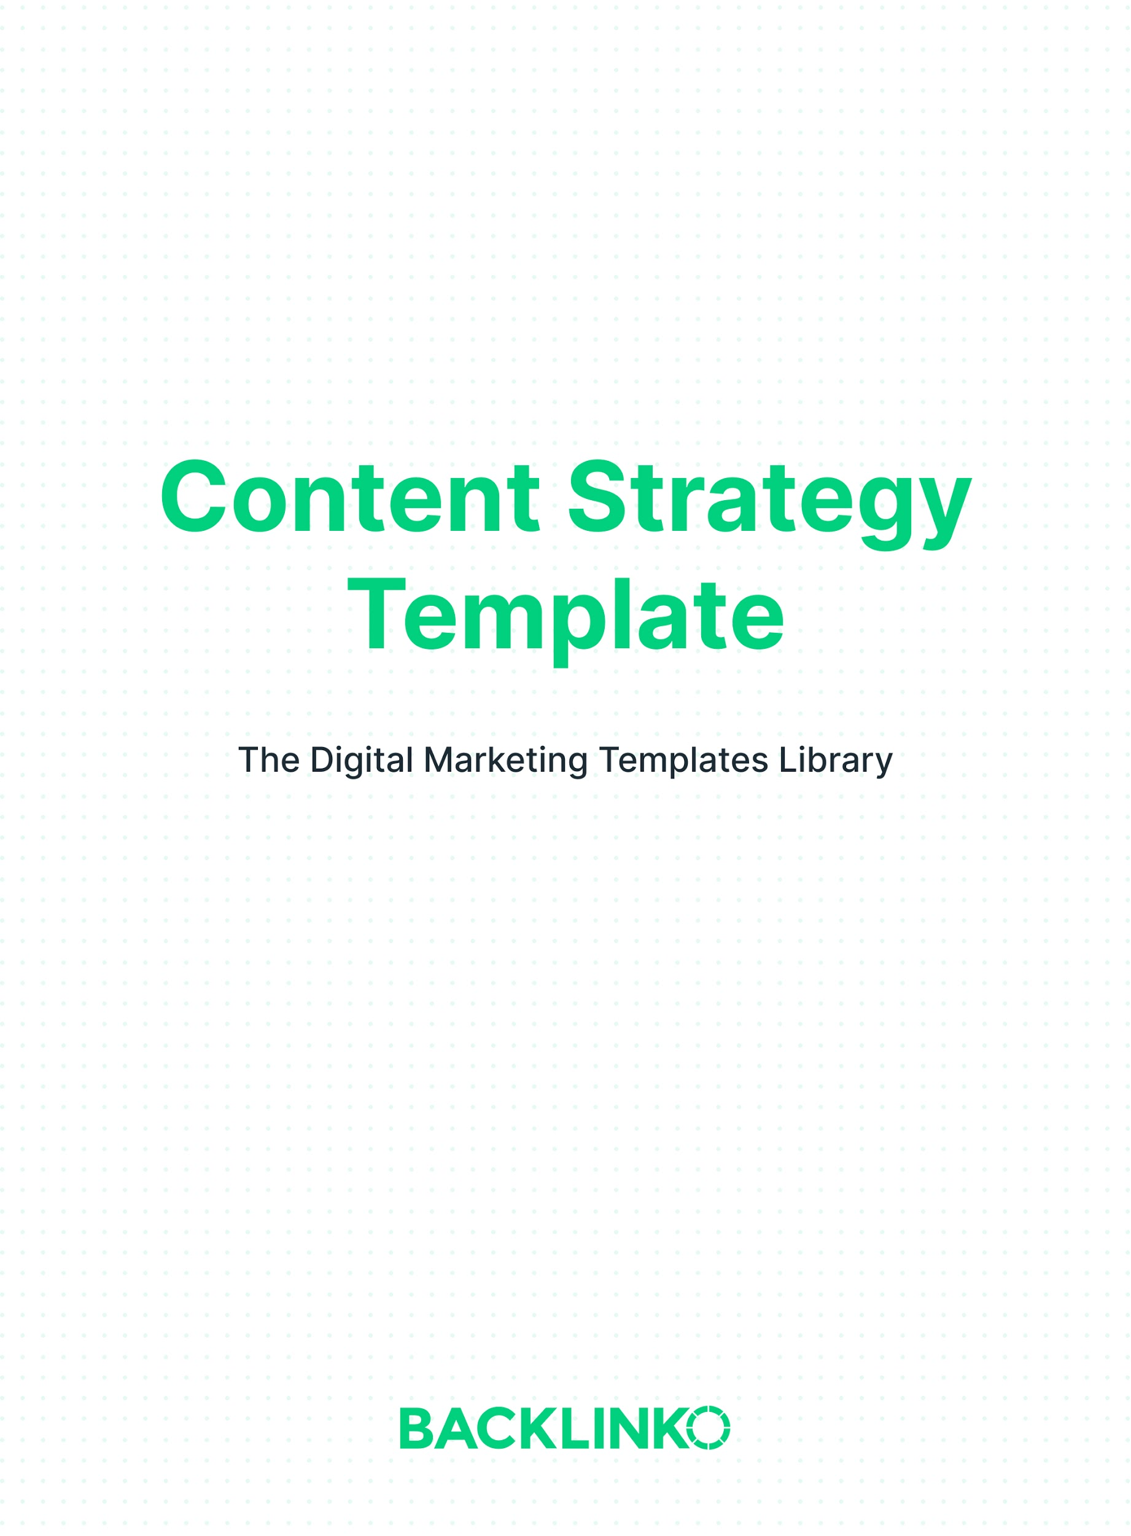

Step 1: Choose Your Goals
The first step in your content strategy is to define your objectives. Otherwise, how will you know if you’re succeeding or failing?

Fill out the table below with the outcomes you want to achieve.

Be sure to include both business-level goals AND content-level goals.

Tip: For help measuring these metrics, see our guide on Google Analytics for Content Marketing.

Business Goals | Content Goals | Details / Timeframe
E.g. Sales of ABC product, email signups | E.g. Traffic to XYZ page, number of linking root domains | E.g. 10% sales growth YoY, add’l 600 subscribers per month

Step 2: Plan Who You’ll Help and How
To create amazing content, you have to know who it’s for.

And you have to know exactly how your content will help them.

Because the more useful your content is, the more it’ll get shared. Linked to. And talked about.

Who | What they need help with
E.g. SEO agency owners | E.g. Getting better results for their clients, training new hires

Step 3: List the Topics You’ll Cover
If you don’t have much of an audience yet, focus on a very narrow subject at first.

For example, most people know me from my SEO content. But at first, I focused solely on one aspect of SEO: link building.

I hammered that subject from every angle for months. And people started to think of my name when they thought of link building. And Backlinko’s audience grew.

I only moved on to other SEO topics after I’d covered link building super thoroughly.

And I only moved on to other marketing topics (like content marketing, copywriting and YouTube) after I covered SEO to death.

Below, list the specific topics you plan to cover in the near term.
E.g. A/B testing
E.g. Exit-intent forms

Step 4: Choose Your Formats and Publishing Frequency
Blog posts. Videos. Podcasts. It’s all content.

You don’t HAVE to push out lots of different content formats. In fact, if you’re just getting started I would stick with just one.

But you should still plan where and when to publish.

Come up with a general direction of how, where and when you want to publish over the next year or so.

Then, refer back to it regularly to stay on schedule. (Or use it to create a full content calendar.)

Format | Publishing location | Frequency
E.g. Product review videos | E.g. YouTube | E.g. Weekly

Tip: If you publish in multiple formats, save time by repurposing your content.

Step 5: Pick Your Promotional Channels
Remember: without an audience, your content isn’t worth anything.

You need a plan to get people in the door.

Not sure how? Check out our guides on content promotion and distribution.

Then, write your chosen promotional methods below.

E.g. Use Buffer to share all blog posts across Facebook, Instagram and Twitter.

That’s it for this content strategy template. I hope you enjoyed it. And remember, you can find 20+ other free marketing templates right here.

Brian Dean
Founder, Backlinko.com

