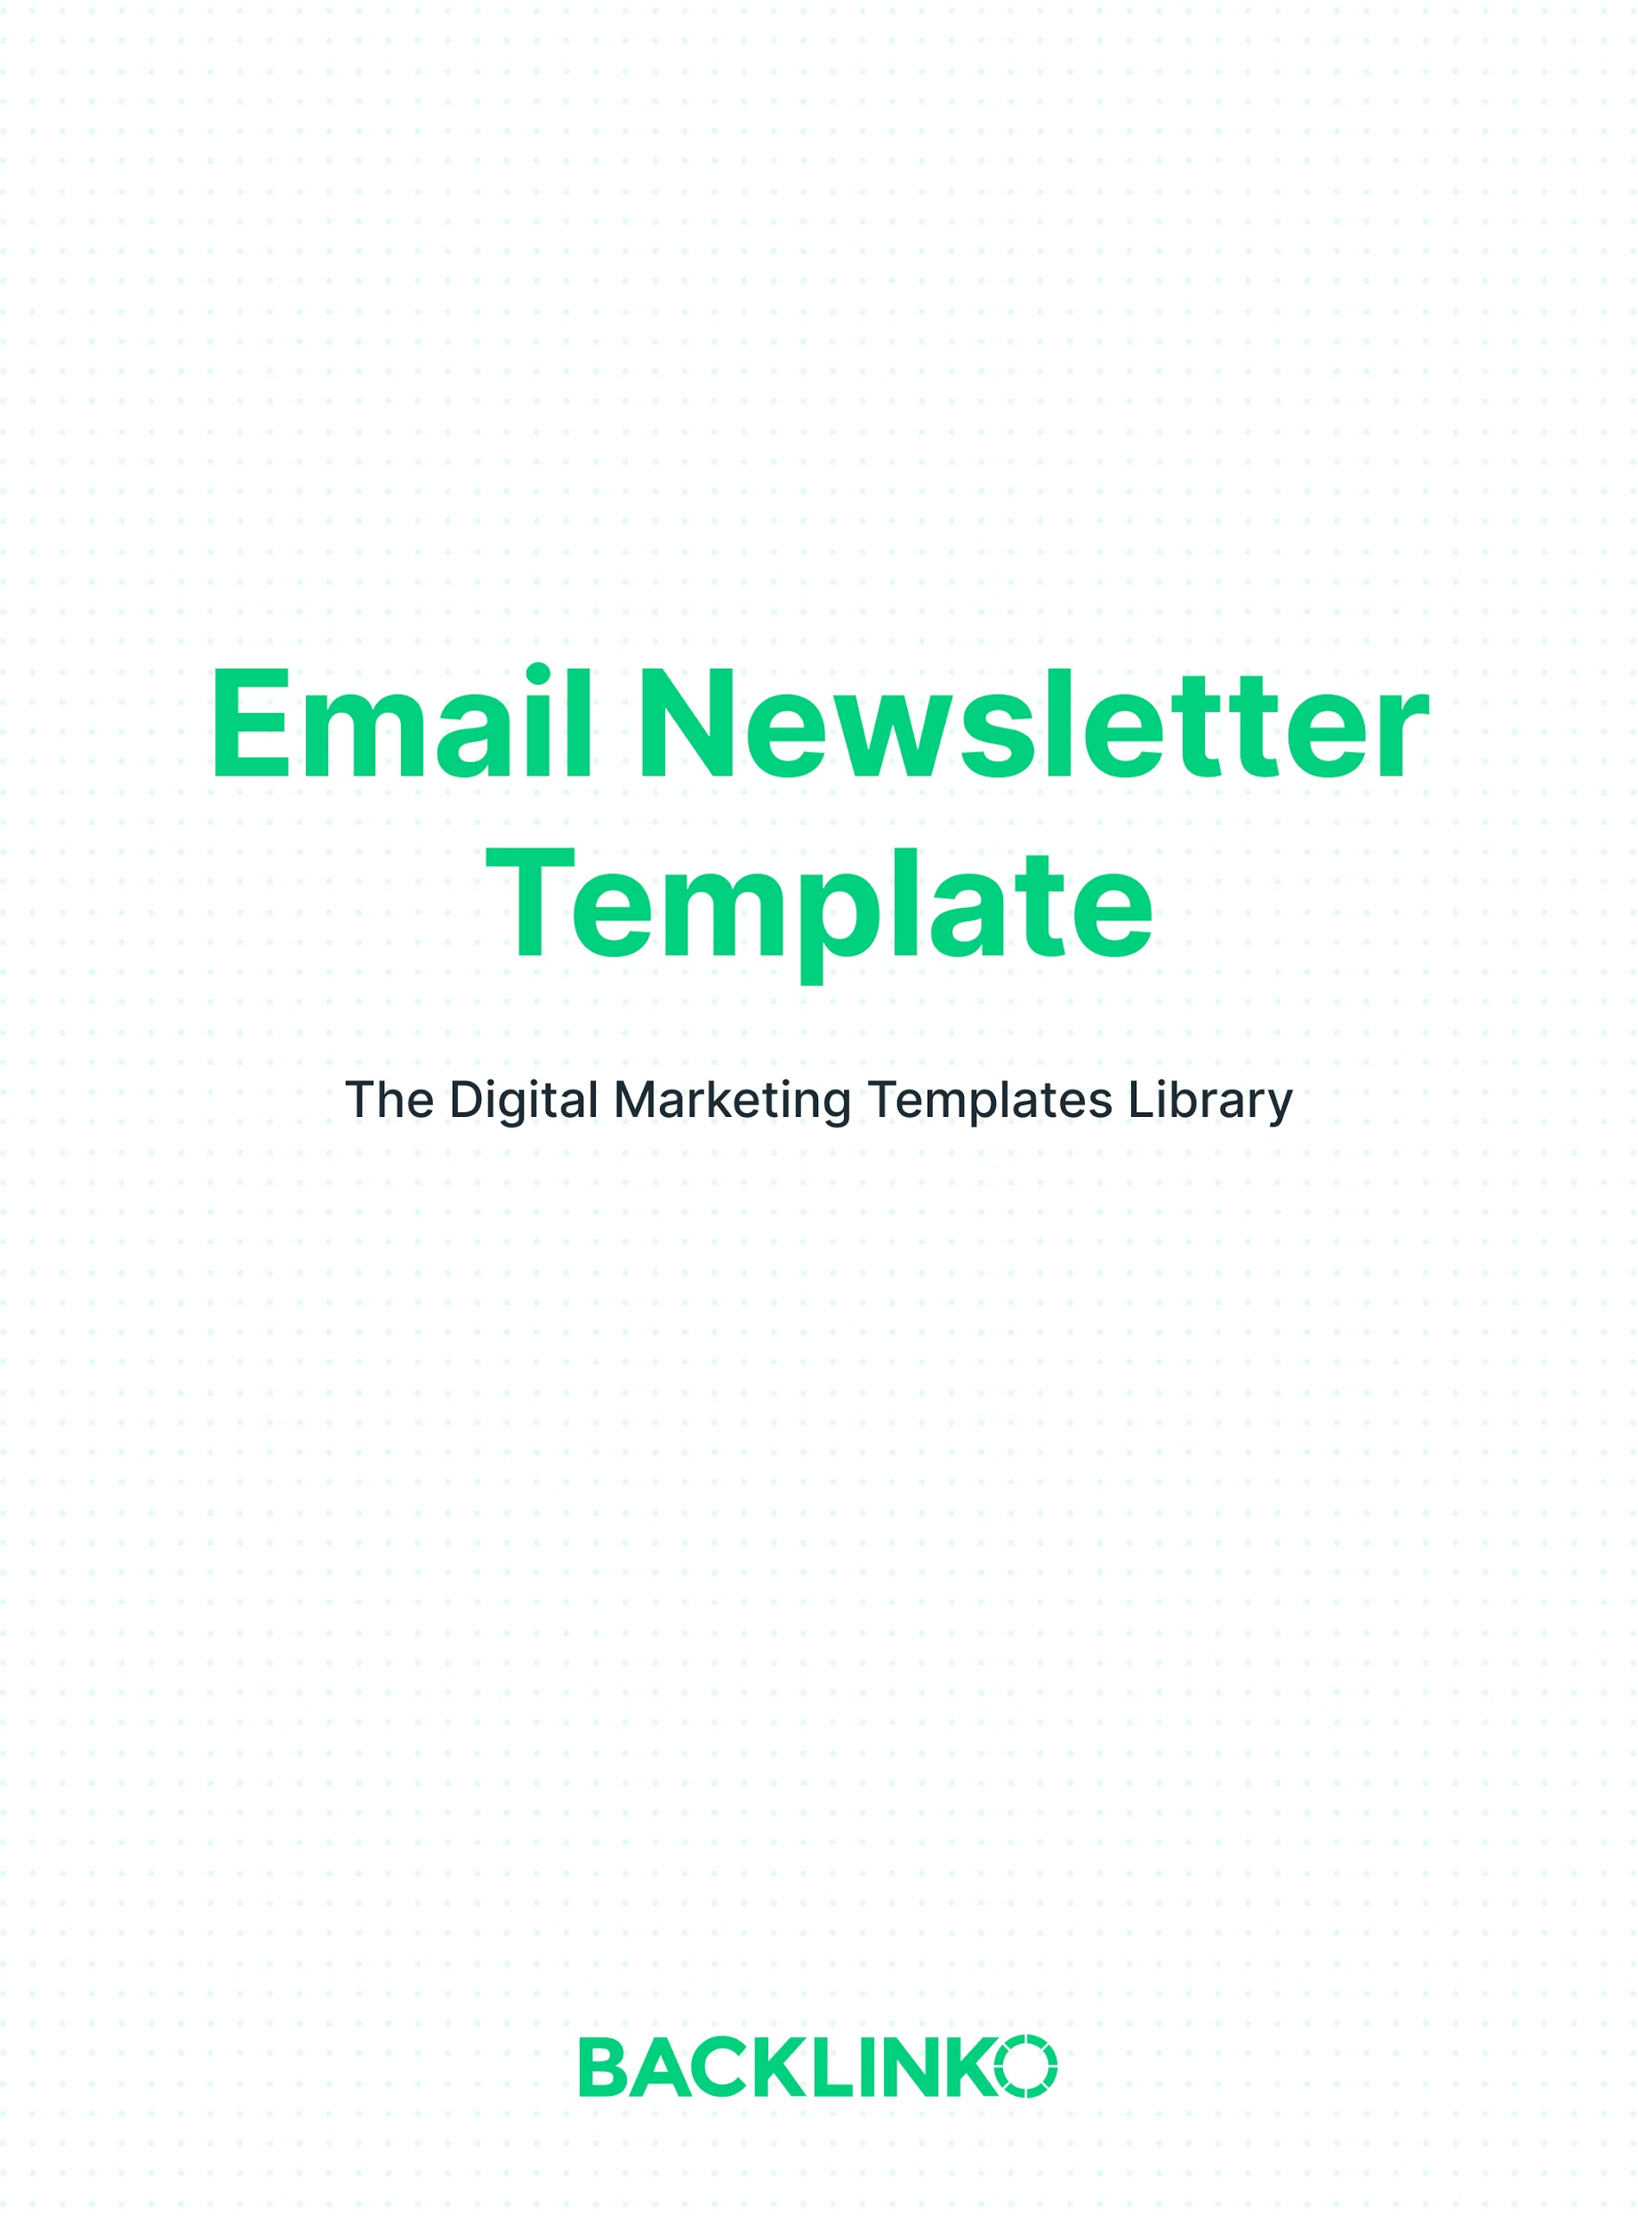

Contents
- My Subject Line Trick
- Tips On Email Body Types
- Include a CTA
- The Template

My Subject Line Trick:
The single most important part of any email is its subject line. Good subject lines get opened. And bad subject lines get deleted or ignored. Period.

After a LOT of testing, here’s my biggest tip for an effective subject line:

Don’t be clever: shorter is better.

(It even rhymes :-D )

So yeah, you just want to use 2-3 words to describe the general topic of your email. And that’s it.

For example, my newsletter with the subject line "YouTube Tags" had an open rate of 59%.

Tips On Email Body Types:
Here are the 2 best ways I’ve found to structure a newsletter email.

1. A mini-story. Telling a brief story in your email is a great way to hook people.

For example:

Hey,

I’ll never forget my first freelance writing assignment…

One day I was searching for writing jobs on Elance. And I saw a job listing that stood out:

“Freelance Writer Wanted for 50 Short Health Articles”

This sounded perfect. So I submitted a bid.

(etc.)
2. A quick preview. This is the structure I use 95% of the time. It’s a little simpler and more straightforward than the mini-story approach. Which makes it great for emails where all you want to do is share some new content with your audience.

With this approach, you just mention a few interesting details about your content. Then link to the full content.

For example:

Hey,

So I just put 10 popular keyword research tools to the test.

(Including Ahrefs, SEMrush and The Google Keyword Planner)

My main goal?

To figure out which tool has the BEST data.

I looked at search volume numbers. I looked at keyword difficulty scores. I even analyzed which tool generated the most keyword ideas.

And in today's post I’m going to show you everything that I found.

Check out the new post right here.

And then leave a comment.

Talk Soon,
Brian

Include a CTA:
You should always include a call-to-action in your emails. Why?

First, because it’s another way you can add value outside of your email. That value might be providing a resource for your subscribers to check out, or just inviting people to reply and interact with you.

The second reason is that you want your readers to get used to engaging with your emails. That way, when it’s important for them to click through (like when you’re pitching a product or promoting some new content), they won’t be caught off guard.

For example:

Reply to this email right now and tell me one thing that you’re struggling with.

Even if it’s teeny tiny… I want to hear about it.

Not struggling with anything in particular? No worries.

Just hit “reply” and say “Hey!” (I love meeting Backlinko subscribers).

You can also call out your CTA more than once, especially if it’s a longer email. The P.S. section is a great place to do this.

For example:

So if you want a step-by-step plan for growing your blog, I highly recommend signing up.

Join Grow Your Blog Fast.

Talk Soon,
Brian

PS: Don’t forget, Grow Your Blog Fast closes tonight at midnight.

If you have a question about the program, feel free to send a message to our Student Support Team at support@backlinko.com. My friendly team is always happy to help.

As always, you're protected by my 30-day, 100% money-back guarantee.

Take the course for a full month. Test out the strategies. Then decide if the course is right for you.

Join Grow Your Blog Fast.

And Now, Here’s The Template:

Subject line:
[Short description of topic]

Body:
Hey [their first name if you have it],

[Body text: Mini-story or quick preview]

[CTA]

[Signature]

[Optional: P.S. section reinforcing the CTA]

I hope you enjoyed this email newsletter template! Remember, you can find 20+ other marketing templates here.

Brian Dean
Founder, Backlinko.com

