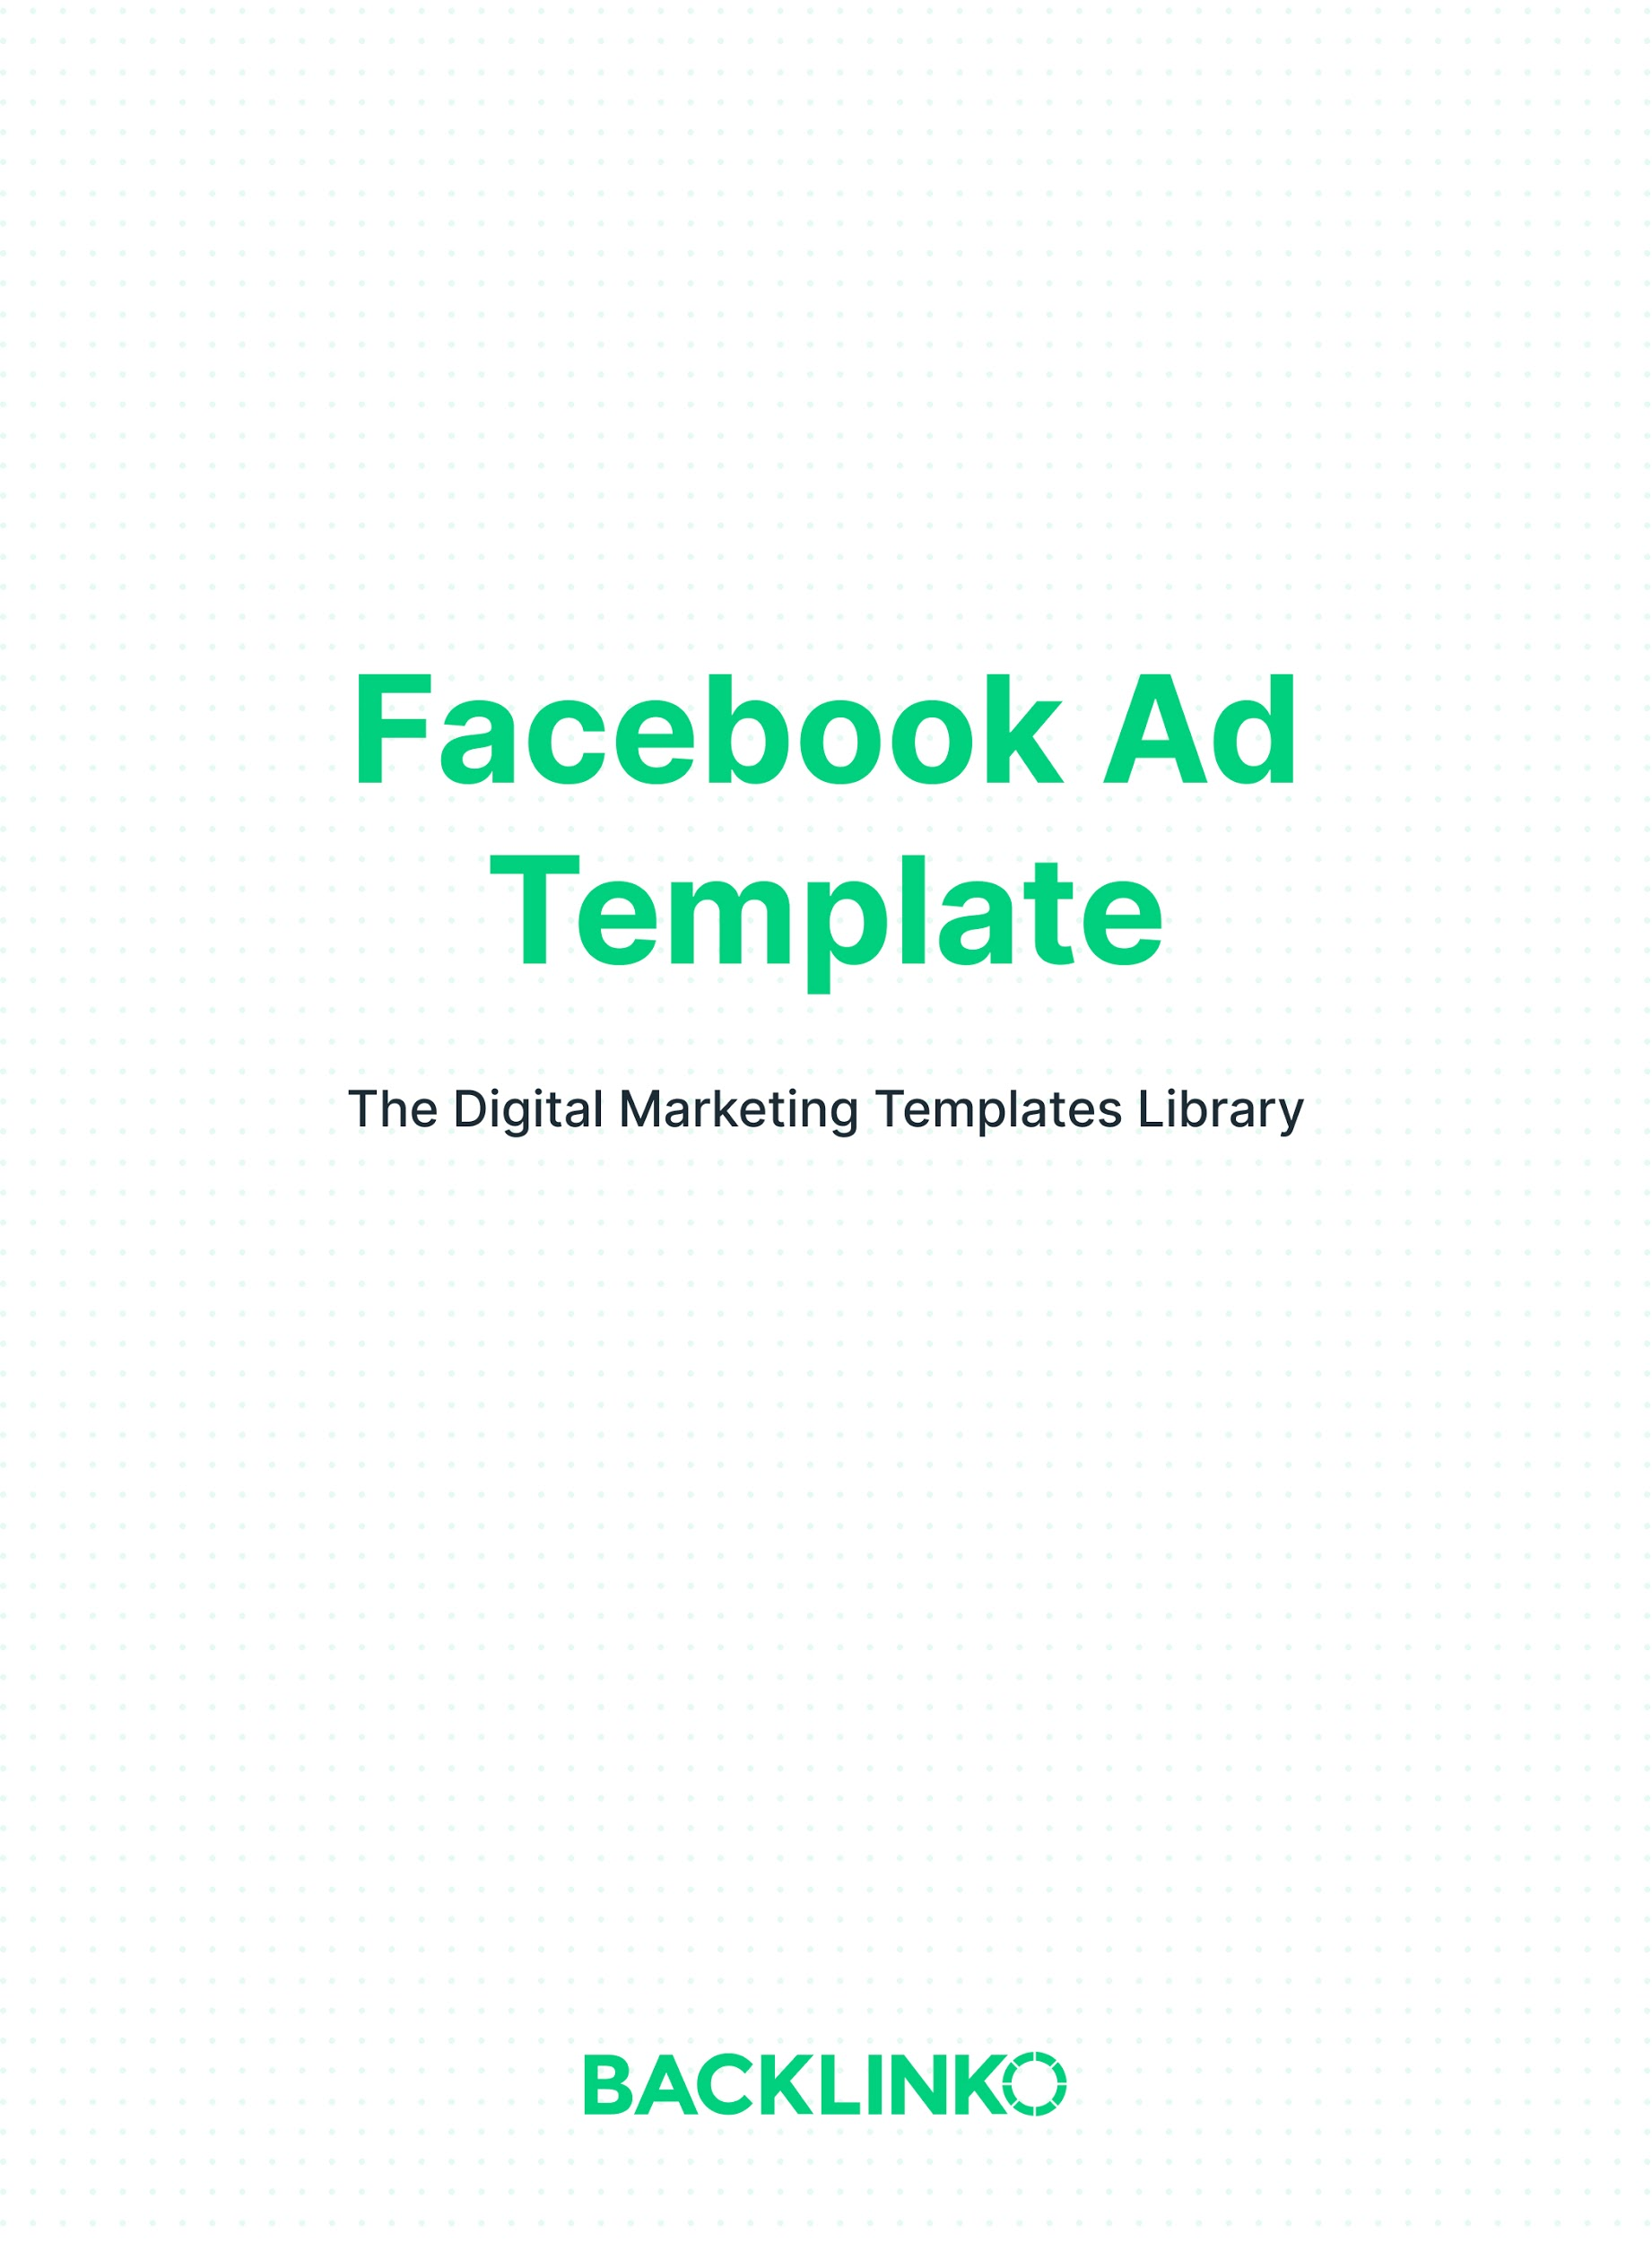

This template covers the 5 main ingredients of a Facebook ad:

- Primary Text
- Image or Video
- Headline
- Description
- Call to Action

Let’s get right to it.

Primary Text
This is the text that appears at the top of your ad. On mobile, only the first 3 lines will be shown at first. So make sure you put your highest-impact copy at the top.

But that doesn’t mean you can’t make your ad a lot longer than 3 lines. People who are interested will click the “See More” link to see the rest. So don’t be afraid to make a good, lengthy pitch to get them to click through to your site.

You can also try using bullet points and emojis.

In the spaces below, write out 3-5 different versions of your ad’s primary text. Make each one quite a bit different.

E.g. We uncover new trends before everyone else knows about them. That's why companies like Apple, Shopify and Casper subscribe to our free weekly newsletter.

So do tens of thousands of entrepreneurs, journalists, VCs, executives and marketers.

You can, too: subscribe today!

(It really is 100% free.)

Image(s) or Video
Your visual imagery is the largest part of your ad, and it needs to be eye-catching.

In fact, along with the primary text, the image or video is the most important part of your ad.

You have 3 main choices for this part of your ad:

- Single image
- Multiple images (for a Carousel)
- Video (which can also be slideshow of multiple images)

You can also include text in your images. Just make sure it covers less than 20% of the image, or it might be flagged as low quality.

Tip 1: Use Facebook’s Text Overlay Tool to check whether you’ve used too much text in your image. And see their guidelines for aspect ratios here.

Tip 2: Use Facebook’s free Video Ad Creation Kit to create videos, or use a paid tool like Animoto for more options.

Headline
The headline displays at the bottom of your ad, next to the call-to-action button. It’s technically optional. But it’s a good idea to include one.

Facebook cuts off headlines longer than 40 characters (including spaces). So keep it brief.

Ideas to try:
- Describe exactly what they’ll get, like “Get Instant Access”
- Use emotionally charged words, like “You’ll Love This” or “Don’t Miss Out”
- Include a number, like “Save $50 Now”
- Use scarcity, like “Last Chance”

In the spaces below, write out 3-5 different versions of your ad’s headline.

E.g. See The Trends (100% Free)

Description
The description appears right below the headline in News Feed placements.

Since it won’t show up in every placement, it’s not the right place for vital information. But it’s a good place to nudge people forward one last time.

In the spaces below, write out 3-5 different versions of your ad’s description.

E.g. Click through to get instant access.

Call to Action
The call to action is the button that’s displayed at the bottom of your ad, next to the headline and description.

You can’t write your own call to action text. But you can choose from over a dozen options including Learn More, Contact Us, Book Now, Download and Sign Up.

Try a couple different options and see which performs best.

Putting it All Together
Now that you have the 5 major ad ingredients, it’s time to turn them into ads.

Tip: Use Dynamic Creative ads. With these, Facebook will mix and match all of your ad elements on the fly. Their algorithms will find the combination that works best to achieve your objective. It’s a HUGE time-saver.

That’s it for this Facebook Ad Template. I hope it was useful! Remember, you can find 20+ other marketing templates here.

Brian Dean
Founder, Backlinko.com

