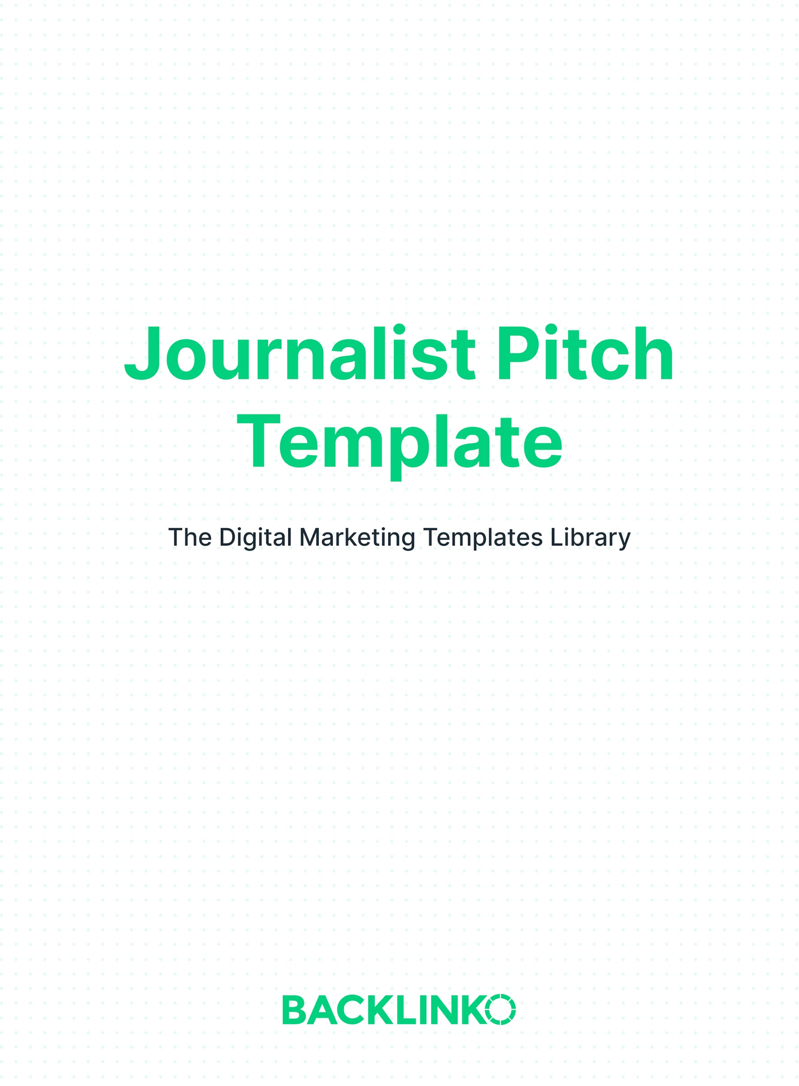

Tips For Writing Great Subject Lines

The subject line is one of the most important parts of your pitch email.

Putting the word “Story” or “Tip” in your subject line will help make it clear that that’s what it is. And including the format of your content (study, infographic, etc.) can help make it stand out too.

For example, “Tip: Why startups are using .co instead of .com domains (Study)”

Tips On The Introduction:

Journalists want to write articles that are interesting and get a lot of pageviews. So your introduction needs to grab their attention and show that YOUR idea can help them with those two things.

At the same time, you don’t want your email to be too long. So cut to the chase with one important piece of info that will get them interested. In the first few lines.

For example, you can relate your news to another story that recently went viral. Or if you’re pitching a study you ran, you can lead with your biggest, most surprising takeaway.

Tips On The Conclusion:

Your conclusion should clear and direct about the one thing you want. There’s no need to be pushy. But you definitely don’t want to beat around the bush.

So in your conclusion, mention the next step… and sign off. Don’t add a bunch more information or other options after your main “ask.”

For example, “Is this something your readers might like? Let me know and [next steps].”

And Now, Here’s The Template:

Subject line:
Tip: [Interesting brief description of your content] [Optional: (Format)]

Body:
Hi [name],

I'm [your name] from [your company], and since you cover [subject they cover that is relevant to your pitch] I thought you might like to know about [brief overview description of your content or story].

[Optional: 2-3 bullet points with short key takeaways or details about your content or story]

Here's the [full piece / press release / other]: [URL]

Does this look like an interesting story idea? Let me know and I’ll send you [any additional materials, e.g. high-res images, full dataset, etc].

Best,
[Signature]

And that’s our journalist pitch template. Remember, you can find 20+ other marketing templates here.

Brian Dean
Founder, Backlinko.com

