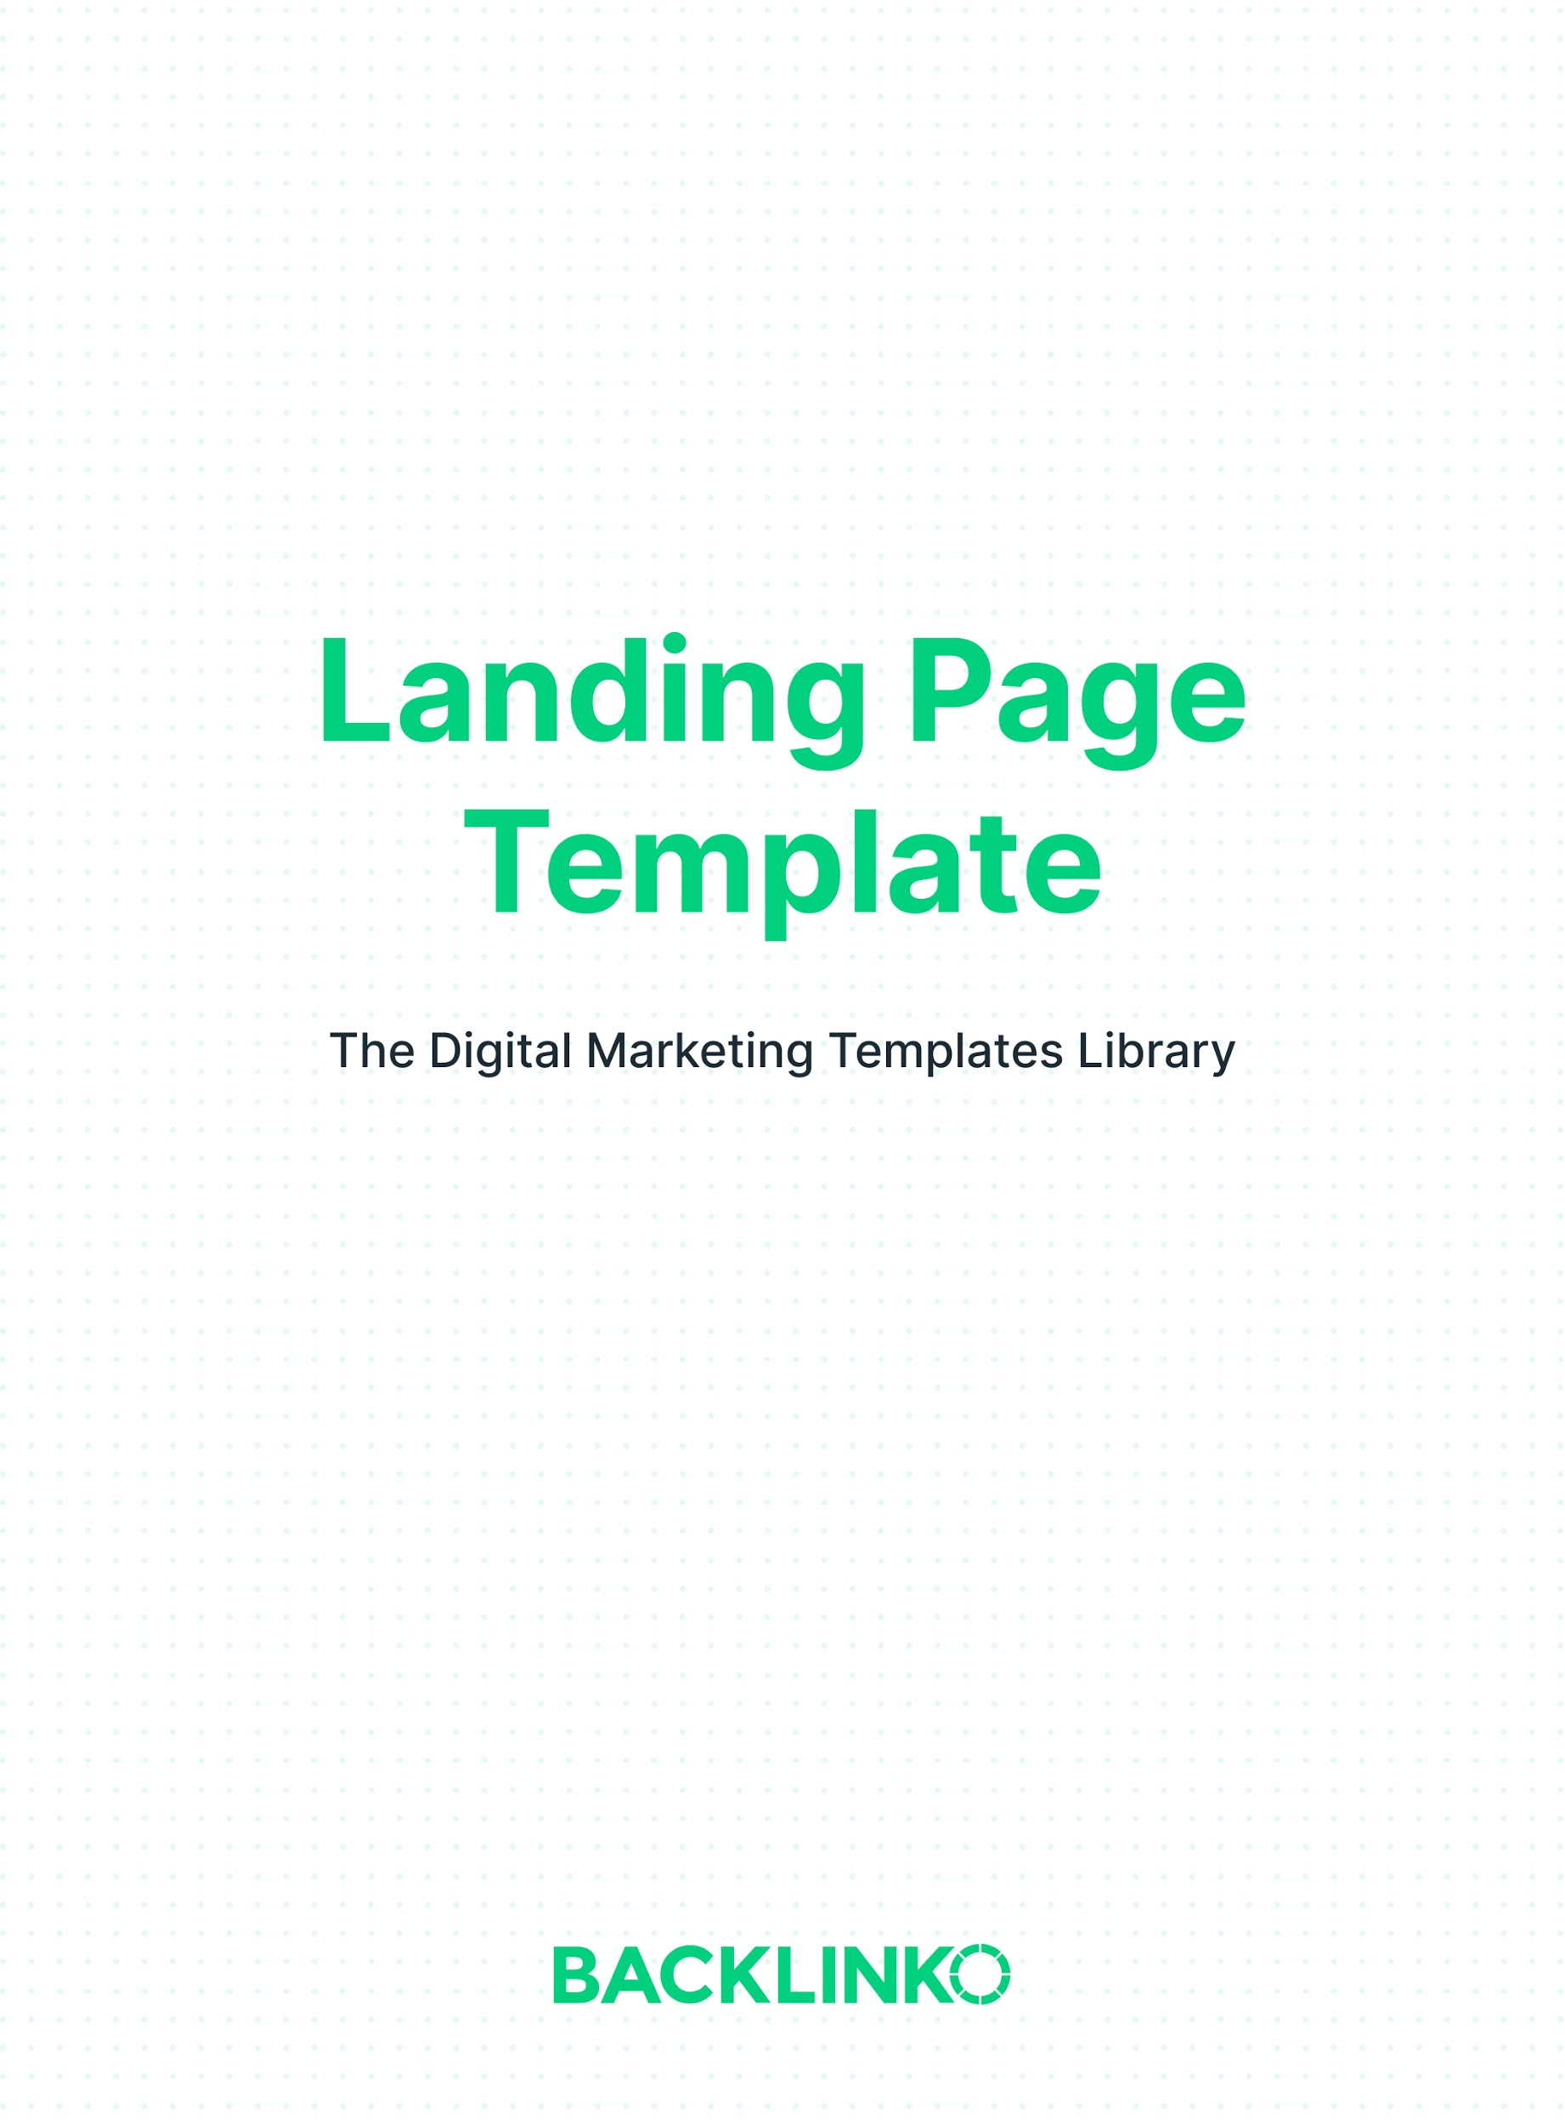

High-converting landing pages typically need 3 things:

- Smart copywriting. This is important in all your marketing. But especially for your landing page. For more on why copywriting matters and how to get it right, check out Copywriting: The Definitive Guide.

- A great, clean design. Remember, your landing page has ONE goal: conversions. Every single thing about it should help with that. Cut away anything that doesn’t.

- The 5 sections below. If you’re offering something for free, you may be able to simplify things even more. (For example, my own newsletter page uses a simplified version.) But if money is involved, you’ll need to make your case with more “show and tell”.

Now, here’s your landing page template.
Replace the example text in each section with your own.

Headline, stating a clear outcome that people will get from signing up or purchasing:

Proven SEO Tips Straight to Your Inbox
Learn How to _____ Like _____
We’ll Double Your Traffic in 30 Days, Guaranteed

First CTA with a compelling offer, letting them know exactly what they’re going to get. (This is a great place to put a signup form, if your goal is to get email subscribers. But if you’re offering a high-dollar item for sale, it’s better to put your first CTA lower on the page.)

Get access to exclusive tips, strategies and case studies not found on the blog.

Social proof

Join 110,424 Others That Get My Weekly SEO Tips via Email

[You can also include logos of companies who subscribe or are your customers, media outlets you’ve been featured in, and/or testimonials.]

Other details, especially if you’re trying to sell something. If you’re offering something for free, you may be able to skip this section.

[More background info about yourself, your product or service. The more expensive it is, the more details you’ll usually need to include. Don’t be afraid to include a LOT of details for big-ticket purchases.]

Final CTA, either simplified, the same as before, or with a different angle:

Sign Up

Optional bonus: exit intent popup:

Free Guide: The Definitive Guide to SEO This Year
Proven strategies to help you get higher rankings.

I hope you enjoyed this landing page template. Remember, you can find 20+ other marketing templates right here.

Brian Dean
Founder, Backlinko.com

