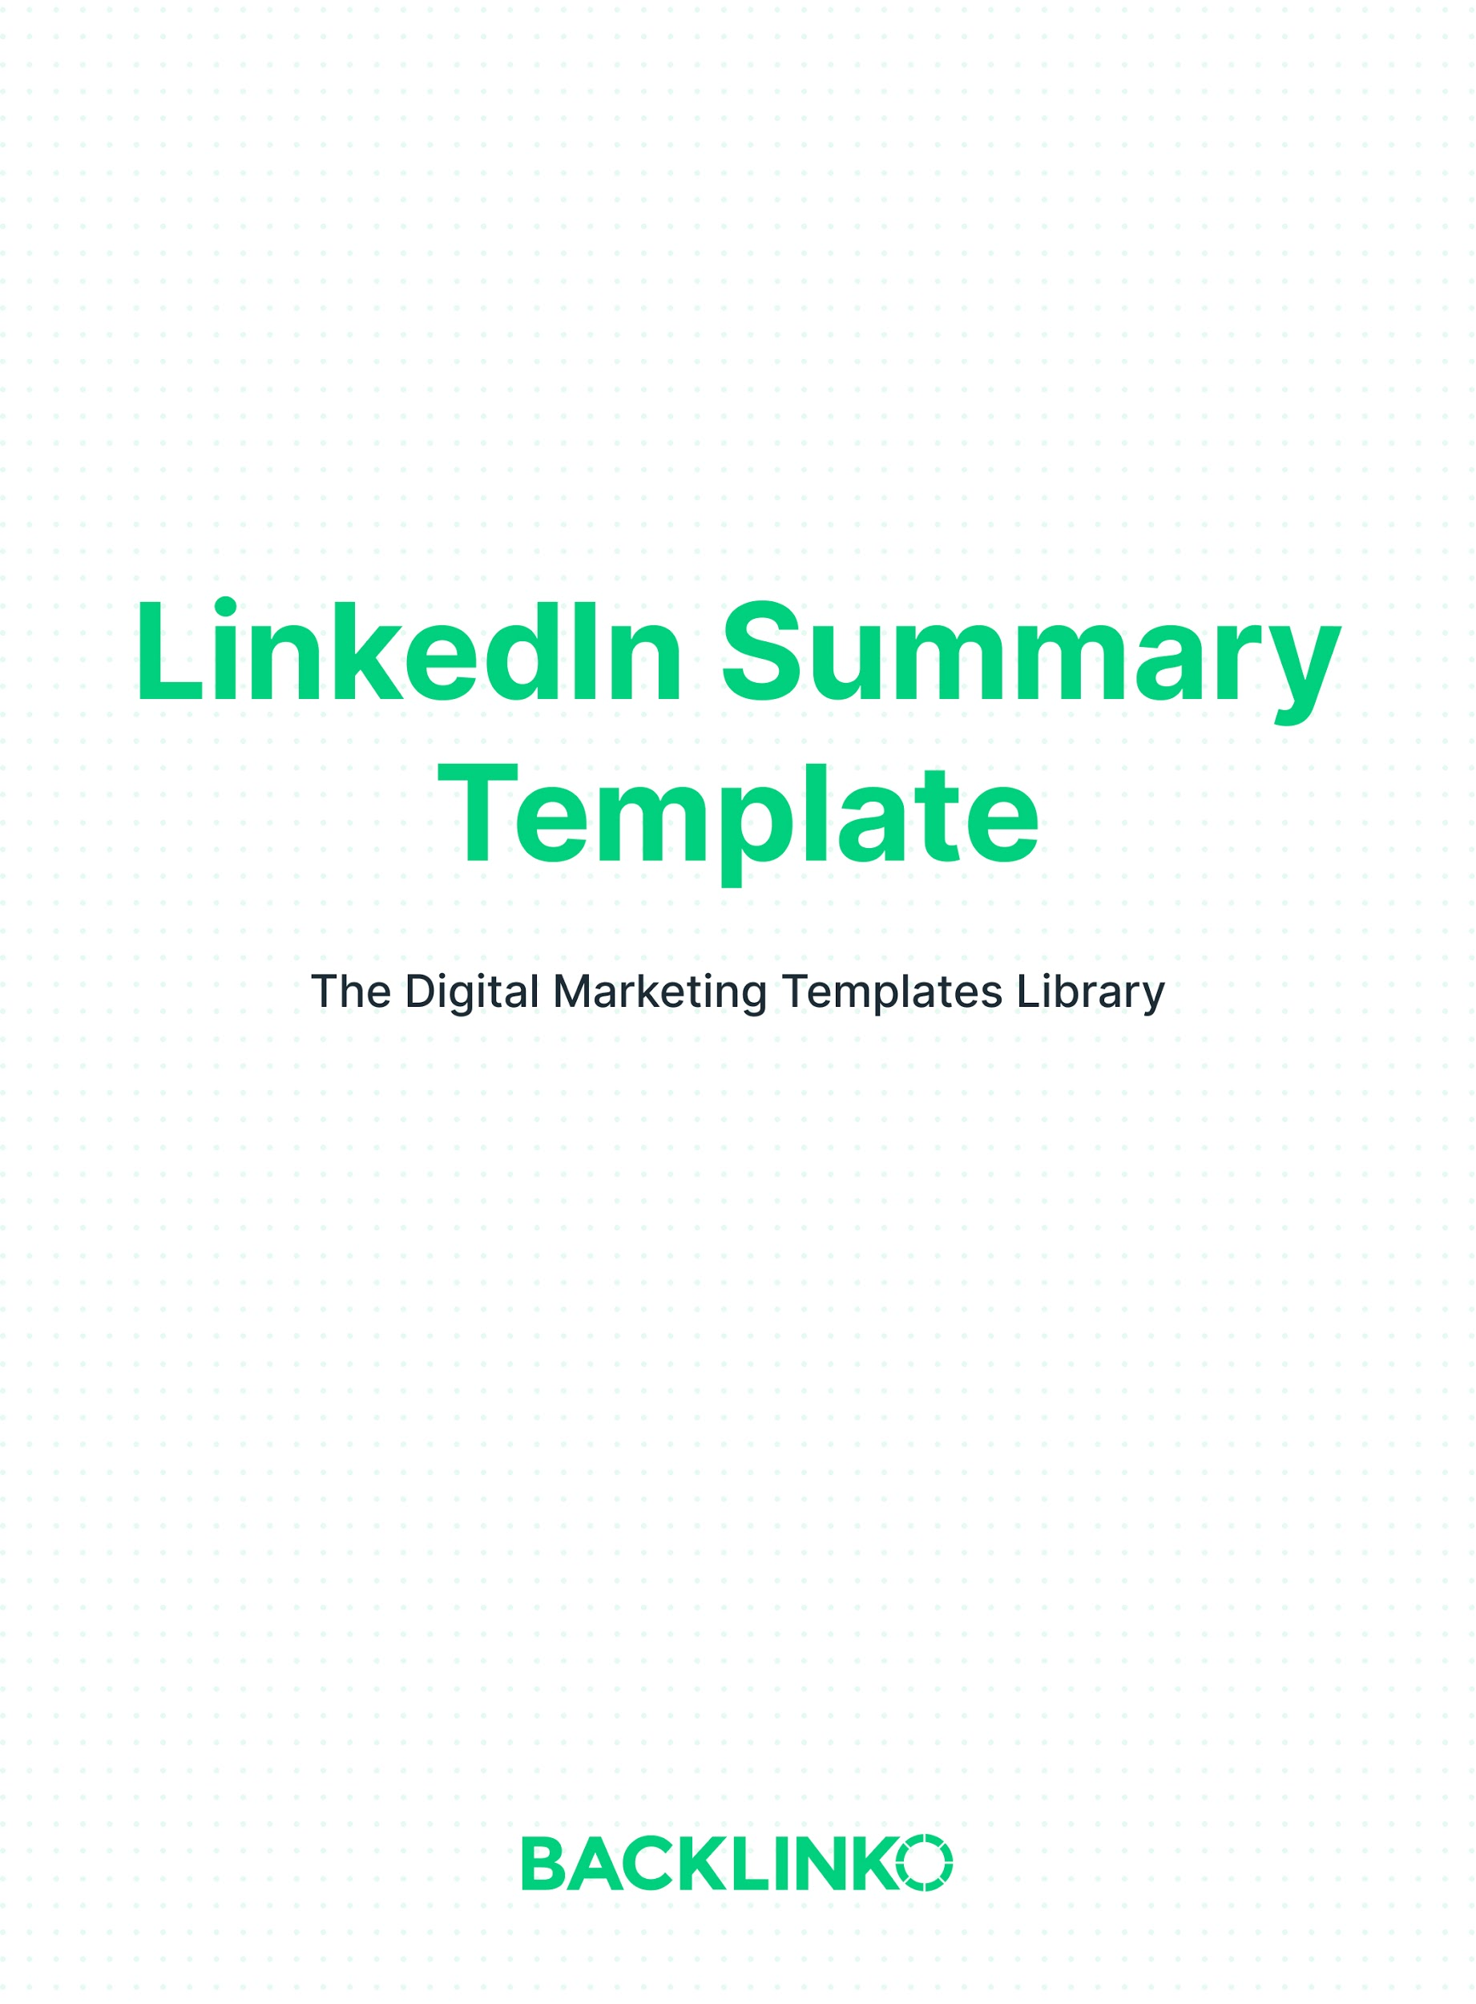
So you just applied for a job. Well, the first thing a hiring manager will do is look at your summary. And even when you’re not actively looking, recruiters will check it out.

(Or if you’re the one recruiting, candidates will take a look as well.)

It’s a major opportunity to let people know why they should work with you.

Think of it this way: your LinkedIn summary is the ultimate cover letter.

Without further ado, here’s your LinkedIn summary template.

Replace the example text in each section with your own.

Part 1: A Catchy Lead
Only the first two lines of your LinkedIn summary are shown by default. The rest is hidden behind a “see more” link.

That means those first lines have ONE purpose: Make them click “see more”.

Here are a few ways you can do that:

Get personal. Even better if you phrase it as a story.

For example:

I’ve been a marketer since I was 6 years old. The first job I ever had was…

Social proof, if a prominent figure or media outlet has talked about you. Or if you’ve worked with large brands.

For example:

“Ashley is the best financial analyst I’ve ever seen.” - Tim Cook

Impressive numbers or accomplishments. Specific accomplishments make a strong impact. Especially if they’re backed up by numbers.

For example:

I’ve closed $18M in ERP software sales since 2017, consistently exceeding my quotas by 40% or more.

Part 2: Your Mission
Now that they’ve clicked “see more”, it’s time to deliver the goods.

Start by telling them what you do and why.

For example:

____ is my passion. I wake up every morning excited to ______.

Why?

In my 13 years of designing websites, I’ve found that ______.

Then, get a little more specific.

For example:

My specialties include SaaS UX Design, Motion Design and UX Writing.

Part 3: Show Them You’re The Best
In this section, it’s time to show off your past successes. And the value you can provide.

Tip: Use bullet points to make this section more skimmable.

For example:
My accomplishments include:
- Increased division sales by an average of 31% per year over the last 5 years (compared to an industry average of 7%)
- Included in Forbes 30 under 30 (2018)
- Won 2020 Brand Impact Award for “Taco Tales” Taco Bell commercial
- Grammy nominated as drummer for Panic! At The Disco

You can also include a “What others say” section here if you’d like to call out any quotes or testimonials not included above.

Part 4: Call To Action
Optionally, you can finish your profile summary with a call to action.

For example:

Want to learn more? I’d love to hear from you. Reach out to me here on LinkedIn, or DM me on Twitter: @example.

And that concludes this LinkedIn summary template. I hope you found it useful. If so, be sure to check out our Digital Marketing Templates Library with 20+ other marketing templates.

Brian Dean
Founder, Backlinko.com

