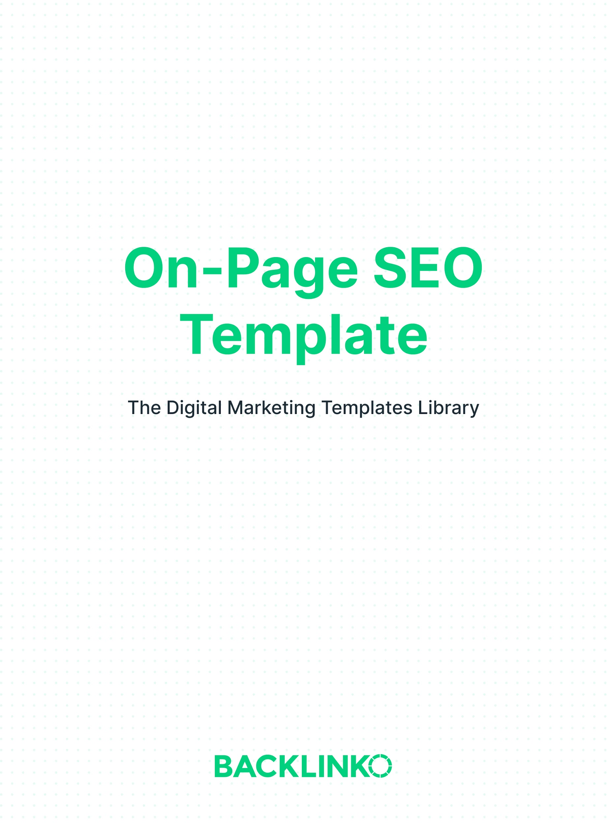
1. My target keyword for this page is: ______

2. Add your target keyword to your page’s URL. For example: mywebsite.com/my-keyword or mywebsite.com/my-keyword-guide

Why It’s Important: Google uses the terms in your URL to understand what your page is all about.

3. Use your keyword once at the top of your page (ideally in the first 50-100 words).

Why It’s Important: Search engines put more weight on terms that appear in prominent places on your page (like at the top).

4. Use your keyword in your page’s title tag.

Why It’s Important: From a Google SEO point of view, your title tag is the most important place to include your keyword.

5. Use your keyword in an H1 and H2 Subheader.

Why It’s Important: This emphasizes to Google that your page is focused on that keyword and topic. H tags aren’t a huge deal for rankings. But every little bit helps.

6. Use keyword-rich image filenames and alt text.

Why It’s Important: Google uses images to understand the content of your page. And descriptive file names and alt text helps them understand what your page is all about.

7. Add internal links to other pages on your site. I recommend including at least 5 internal links per page.

Why It’s Important: Internal links can help Google find, crawl and index more pages on your site (and help them rank higher in the search results).

8. Add external links to other helpful websites and resources.
Why It’s Important: External linking to related pages helps Google figure out your page's topic. So I recommend adding lots of external links to pages that will help your users learn more about something that you cover on your page.

9. Use synonyms and related terms.

Why It’s Important: In other words: include variations of your target keyword on your page. For example, if your main keyword is “kettlebell workout”, use variations like “kettlebell exercises” and “easy kettlebell movements”.

10. Write an enticing meta description.

Why It’s Important: Although using keywords in your meta description isn’t a ranking factor anymore, organic click through rate is. And when Google searchers see a compelling meta description in the organic search results, they’re more likely to click on your site.

11. Make your site work with mobile devices.

Why It’s Important: In other words, your site should be mobile-optimized for Google users and search engine crawlers. Google’s index is now “mobile-first”, which makes mobile usability an absolute most for SEO.

12. Use structured data.

Why It’s Important: Structured data (Schema) can help your site feature “Rich Snippets” in the search results.

13. Match search intent. Double check that your page is a 1:1 match for search intent. The best way to do that? Check out Google’s first page for that keyword. If they’re all a specific type of page (like a list post or ecommerce product page), you want your page to be in-line with what’s already ranking.

Why It’s Important: If your page doesn’t satisfy search intent, your page most likely will not rank for that keyword (even if you have lots of backlinks). It’s that important.

14. Decrease bounce rate. In other words: make your content “sticky” so that Google users stay on your page...and don’t bounce back to the search results.

Why It’s Important: Bounce rate probably isn’t a direct Google ranking factor. But it might be. Especially if that bounce leads to “pogosticking”.

15. Write a title tag that’s keyword optimized and engineered for clicks. The best way to do this is to think of what you would want to click on if you were searching for your target keyword.

Why It’s Important: Like I mentioned back in item #10 from this list, a high CTR can boost your rankings. And your title tag is a BIG factor in what people use to decide what to click on.

That’s it for this on-page SEO template. I hope you enjoyed it! Remember, you can find 20+ other marketing templates here.

And if you want a more in-depth look and further explanation of everything in this template, check out my Definitive Guide to On-Page SEO.
Brian Dean
Founder, Backlinko.com

