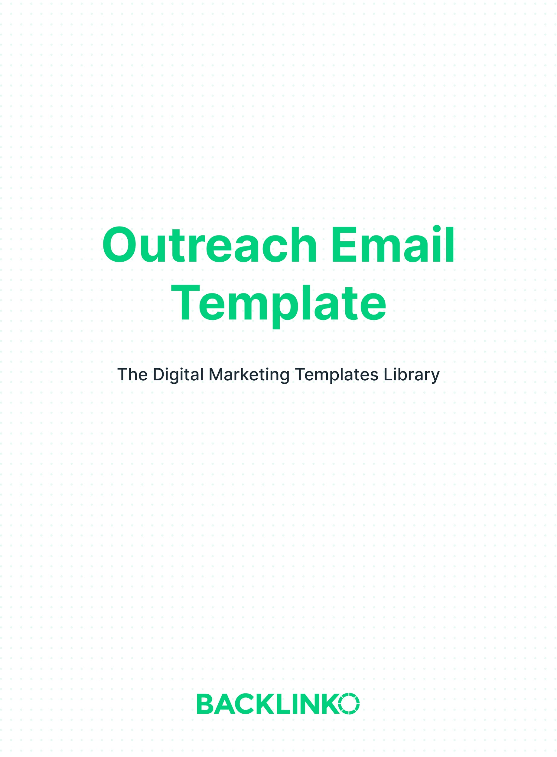

This document contains 3 types of email templates:

- Templates for Building Backlinks
- Templates for Getting Social Shares and Building Relationships
- General / Miscellaneous Template

Templates for Building Backlinks
Backlinks are one of the biggest ranking factors in SEO. And I believe they’ll still be important 10 years from now.

The following templates will help you build more of them, faster.

Template #1: Broken Link-Building

Broken link-building is one of the oldest link building strategies out there.

With BLB, you reach out to sites that are linking to a broken page. And let them know about a similar (but working) page on YOUR site… and suggest that they fix their link with a link pointing to your page.

Subject line:
Quick note about a dead link of yours

Body:
Hi [name],

I noticed that your awesome post [title of their post, linked to its URL] is linking to a broken page.

It’s linking to this URL: [broken link URL], which as you can see is no longer working.

I actually recently published a [description of your content] that covers a lot of the same info that the broken page did: [title of your page, linked to its URL]

It might be a good replacement :-)

Either way, keep up the great work!

[Signature]

Template #2: Resource Pages and Link Roundups

Resource pages and link roundups are two of the easiest places to get links from. Why? Because their authors are LOOKING for valuable content to link to.

However, this also means they get TONS of spammy emails. So your outreach needs to be on point.

Subject line:
Quick question about your latest post

Body:
Hi [name],

I was looking for some info on [topic] today when I found your awesome [name of page].

Great resource!

[Favorite item from their list] was especially interesting. [A sentence on what you liked about it]

I also realized that I recently published a page about [topic they cover]: [URL of your page]

It [short description of your page].

It might make a nice addition under the [section name] of your page.

Anyway, thanks again for the great resource.

Have a great day!

[Signature]

Template #3: The Skyscraper Technique

The Skyscraper Technique consists of creating a much better version of an existing piece of content. Then, reaching out to the people who linked to the older piece to let them know about your new-and-improved version.

Subject line:
Question about your post on [topic]

Body:
Hi [name],

I loved [personalized sentence or two] on your [title of their page, linked to its URL].

One thing I also noticed is that you’re linking to this page on [topic] -- [URL of older, existing piece]

So I wanted to let you know that I created something similar, but more thorough and up to date:

[URL of your new version]

Might be worth a mention on your page.

Either way, keep up the awesome work!

[Signature]

Templates for Getting Social Shares and Building Relationships
Yes, backlinks are critical for SEO success. But social shares can bring in huge spikes of traffic and exposure on their own. So they’re worth getting.

And this especially true if you can get people with a lot of followers to share your content.

The next two templates are all about making that happen.

(As a bonus, these templates can also help you build relationships with bigger names in your space.)

Template #4: The Content Roadshow

With “The Content Roadshow”, you reach out to people who have shared content on your topic before. And let them know that you’re about to publish something related.

If you have time, interact with these people on social media or comment on their blog. Then, you can reference that in your email. (For example: “Thanks for responding to my comment earlier.”)

Subject line
New [description of your content]

Body
Hi [name],

I saw that you [tweeted/shared on Facebook/etc.] [author]’s post about [topic] last week.

What a great article.

I’m working on something related that I thought you might be interested in. It’s [description of your content].

Is it OK if I send it your way when it’s done?

[Signature]

Template #5: The “No-Ask”

While most of these templates don’t ask for anything big up-front, this one goes as far as pointing out that you’re not asking for anything.

Surprisingly, this “judo move” can actually lead to more shares.

As usual, the key is to add value first: in this case, by linking to or featuring the person’s content. But you can also tweak this template to let them know you’ve shared their content or simply to say “thanks” for inspiring your post.

Subject line:
I just featured your work in an article

Body:
Hi [name],

I loved your article on [topic], [title of their article].

So much so that it inspired me to write my own post covering [description of the way you tackled the topic].

Naturally, I gave you credit in my article. (Here it is if you’d like to check it out: [URL of your post])

Don’t worry, I’m not looking for a share or anything. Just wanted to say thanks for the inspiration!

[Signature]

General/Miscellaneous Template
This last template is a catch-all for just about any outreach you might do. It’s a basic but flexible blueprint.

In most cases, it pays to try to keep your request in the first email as small as possible (for example, asking if you can send them a link to your article vs. asking for a share right off the bat).

That makes it easy for them to say “yes”. Then, you can make your bigger request.

Template #6: The General Template

Subject line:
[Specific subject line]

Body:
Hi [name],

[Provide value. For example, by pointing out an issue with their website, letting them know you shared their content, or by paying them a compliment.]

[Indirect or small “request”]

[Signature]

That wraps up this list of outreach email templates. Remember, you can find 20+ other marketing templates here.

Brian Dean
Founder, Backlinko.com

