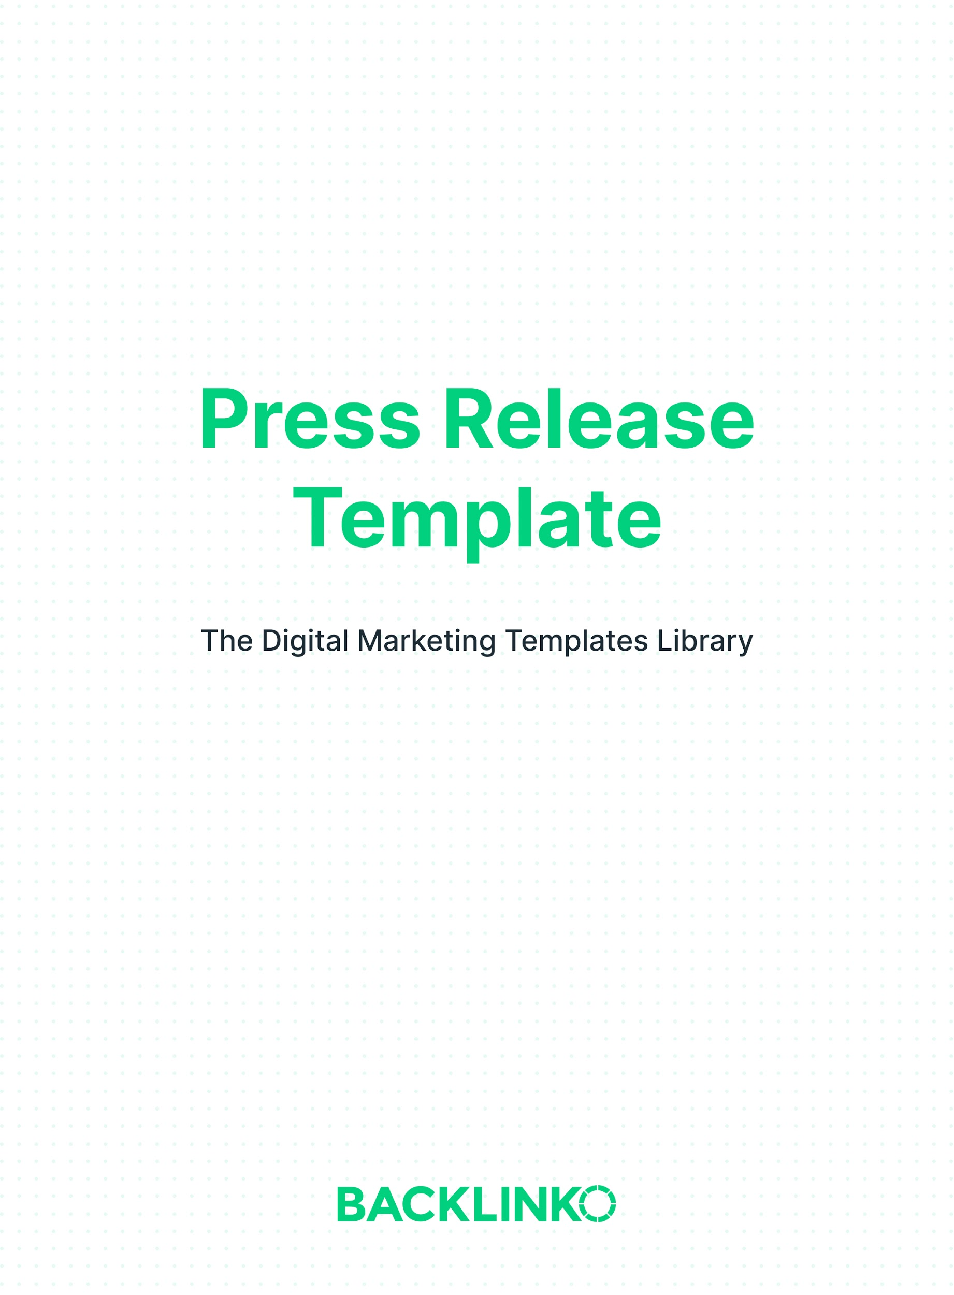
A press release is a powerful tool to spread the word about your organization. There are two key things every press release needs:

- Newsworthy content. It doesn’t need to be earth-shattering, but it should at least be new. It has to be interesting enough to get bloggers’ and journalists’ attention… and get THEIR readers’ attention, too.

- Quality, skimmable copy. Most people won’t read your release word-for-word. So it’s important to format your release for skimmers. Use simple sentences. Bullet points. And short, fluff-free paragraphs.
For more tips on writing engaging copy, see this guide.

And with that, here’s your press release template.
Replace the example text in each section with your own.

Your hook, designed to appeal to a wide audience:

Internet Users More Likely to Share Long-Form Content

Tip: See more on writing a great hook here.

Headline, featuring your hook:

Internet Users More Likely to Share Long-Form Content,
New Study by BuzzSumo and Backlinko Finds

Your lead, highlighting the most interesting part of your release:

Long-form content results in 56% more social shares than content shorter than 1,000 words, according to new research from BuzzSumo and Backlinko.

PR body copy, written in the 3rd person so that journalists can copy and paste:

The research, which analyzed over 900 million articles, also discovered that long-form content was correlated with better backlink performance. Specifically, posts weighing in at more than 3,000 words receive an average of 77.2% more referring domain links than short articles and blog posts…

(etc.)

Tip: Check out a full Backlinko press release example here.

Your contact info:

Media Contact
Your Company
John Doe, +1-555-567-8899
john@company.com

Tip: Let journalists know that you can provide more help or resources with a note like: “If you have any questions about this release, don’t hesitate to get in touch.”

Boilerplate info about your company:

[Company name] is a ______ that helps ______ do ______ by ______.

I hope you enjoyed this press release template. For an even more detailed step-by-step method I use, check out How to Write a Press Release: The Definitive Guide.

And remember, you can find 20+ other marketing templates (including more for public relations) right here.

Brian Dean
Founder, Backlinko.com

