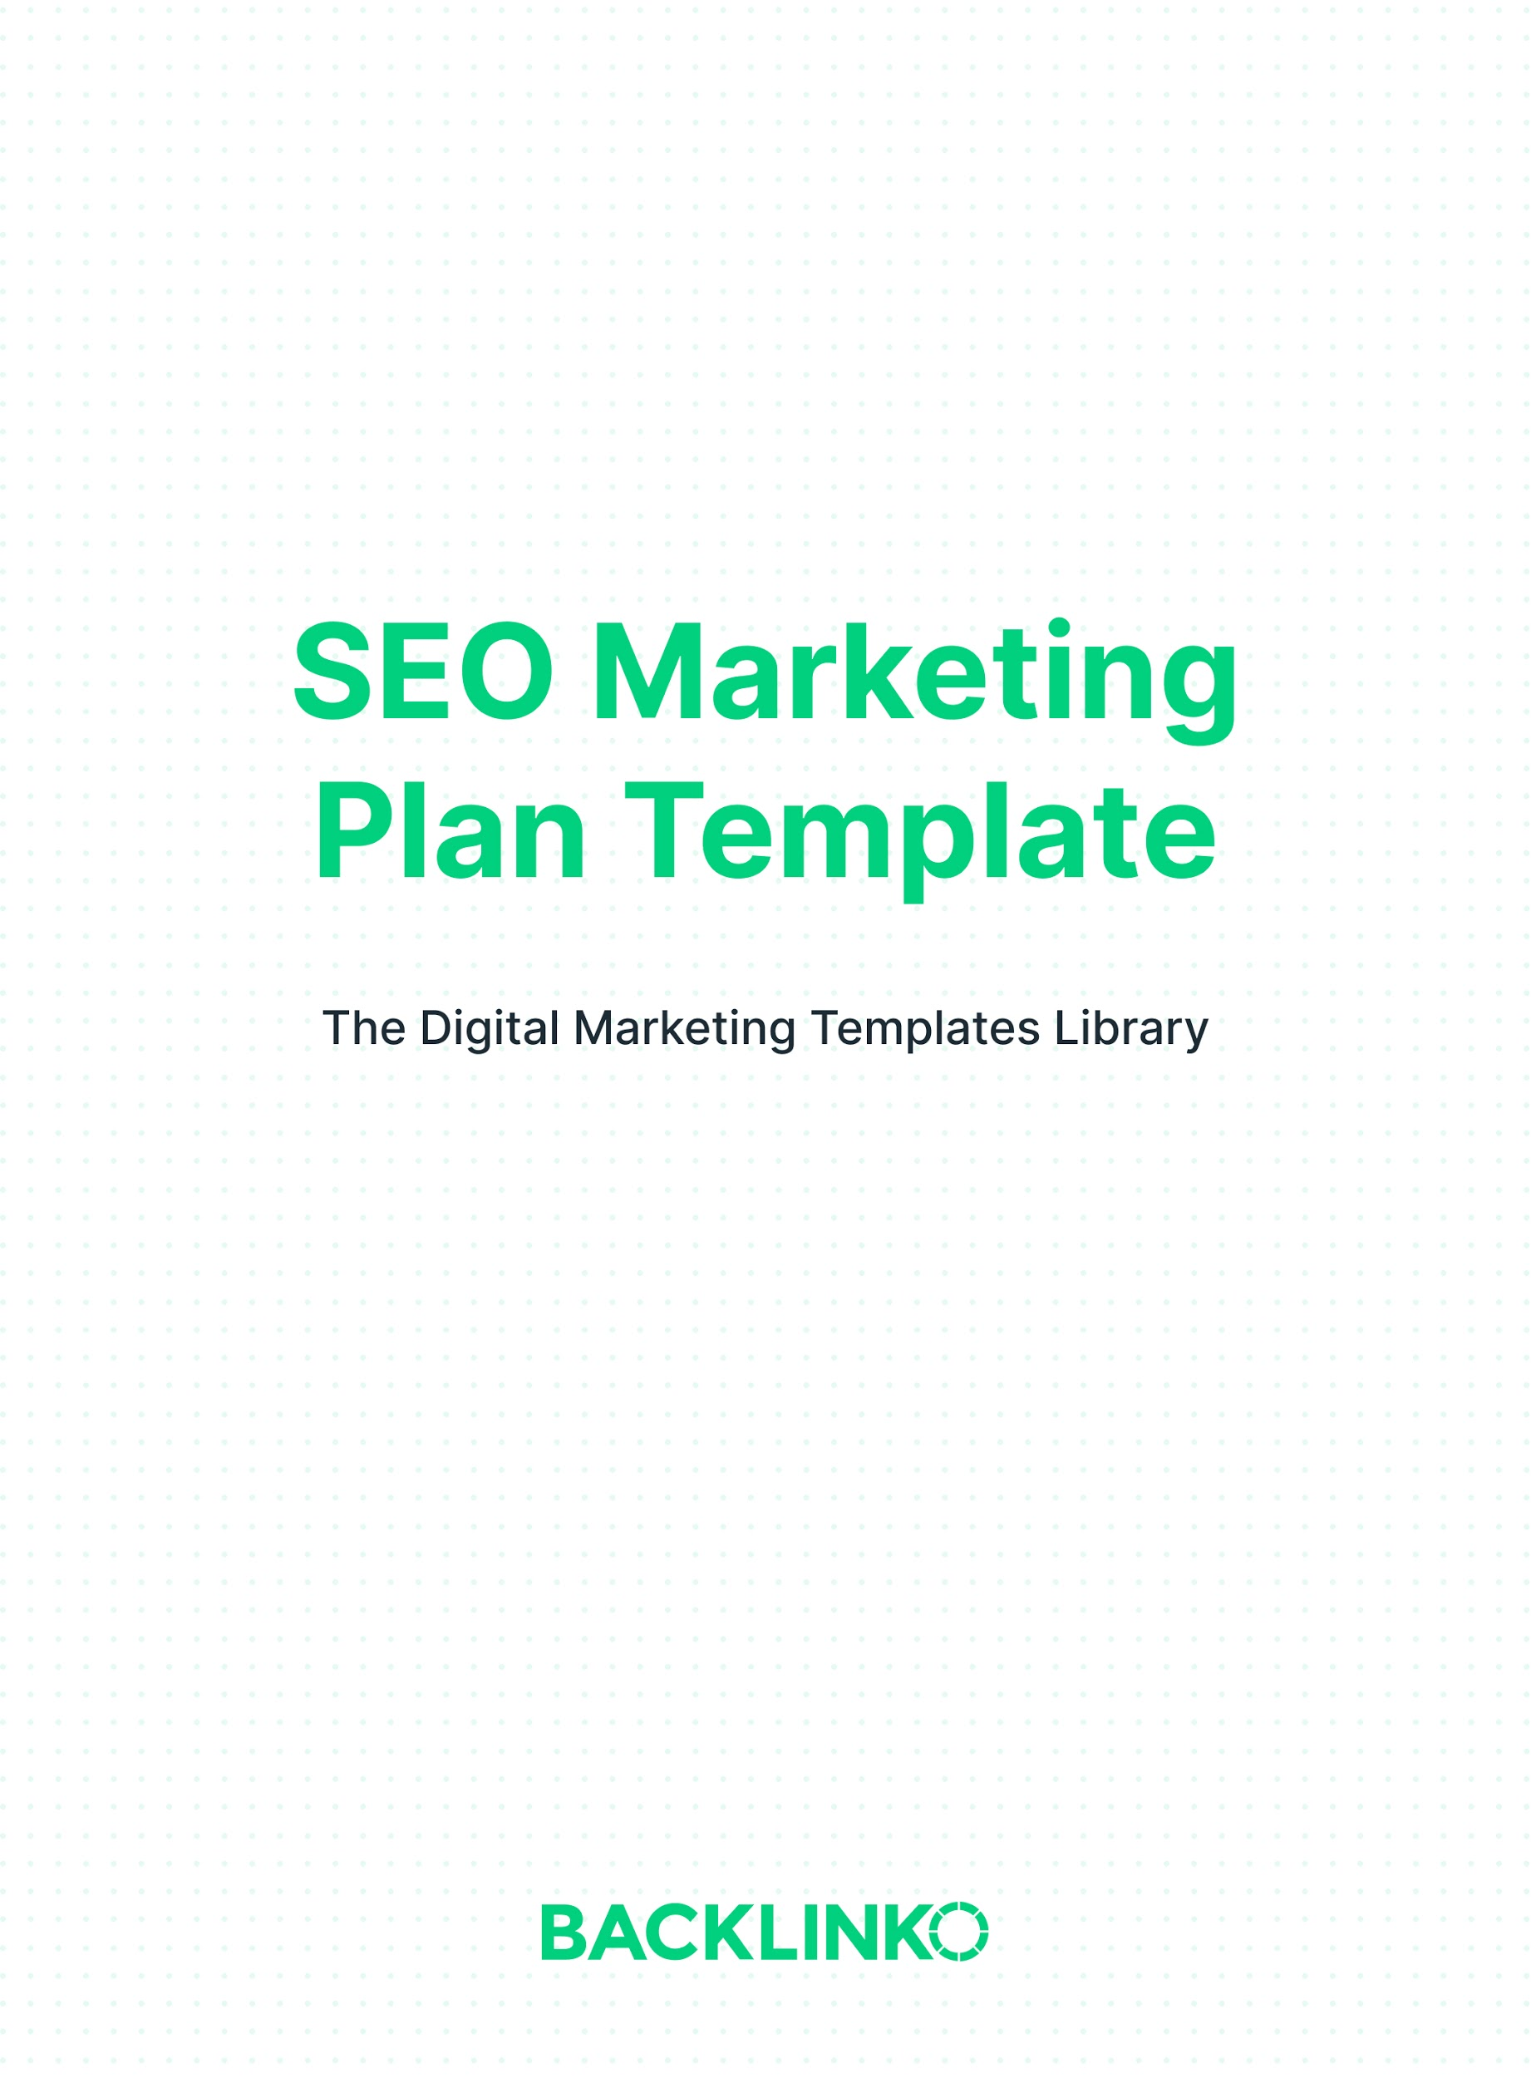
This SEO marketing plan template includes the key steps you’ll need to rank for a specific keyword in Google. That said, if you haven’t already, I recommend checking out our SEO Strategy Template first. It will help set the foundation for what’s covered here.

Step 1: Find a Target Keyword
The first step in your SEO marketing plan is to choose a keyword to target.

In other words: it’s time for keyword research. First, you want to create a list of several different keyword options. Then, prioritize them based on their balance of commercial intent, search volume, competition, and relevance to your business.

You can add them here:

Keyword | Commercial Intent | Search Volume | Competition | Relevance
E.g. Olympic weight sets free shipping | E.g. High | E.g. 200 searches/mo. | E.g. Low | E.g. Somewhat relevant

Finally, pick 1 keyword from the list.

(See also: Our Keyword Research Template.)

Step 2: Create Your Content
Now it’s time to create your content based on the keyword you selected.

Pick a Format Based on Search Intent
Plug your keyword into Google and look at the first page of results.

Are they all how-to guides? List posts? Product reviews?

The top-ranking pages tell you what Google believes the search intent for your keyword is. To rank well for that term, it’s a good idea to use the same format for your own content.
Write It
Write your content with these tips in mind:

- Go in-depth. Long-form content gets 77.2% more links than short articles.
- Remember what you saw on the first page of Google? To stand out, it’s important to make your content a LOT better (or different) than what’s already out there.
- Take inspiration from other, unrelated content. Look for trends in what’s hot on AllTop, BuzzSumo, or Ahrefs’ Content Explorer. Mimic what you can, like patterns in the structure of headlines.

(See also: Our guide to SEO Content.)
Set a Date to Revisit and Refresh It
It’s a good idea to refresh your content now and again. This helps your work stay relevant and useful. Google also typically gives fresh content a slight edge.

I refresh my most important posts at least once per year.

It’s a lot easier to do that if you schedule a time to refresh it the moment you finish writing it.

So right now, set a reminder or write a note in your content calendar to refresh this content a year from now.

Step 3: Optimize Your Content
Optimize It for Search Engines
On-page SEO is extremely important.

Here are 3 key things you can do to optimize your content for search engines.

- Include your target keyword in the page’s URL, title tag and headline.
- Write a meta description that will make people want to click.
- Use your target keyword, synonyms and related terms throughout the page.

For more on-page SEO items to tackle, use our free On-Page SEO Template.

Optimize It for Users
Optimizing for Google is important. But you want to optimize your content for people, too.

Use Readable to make sure your writing is easy to read and understand.

And use SEO copywriting tricks like super-short paragraphs and “bucket brigades” to keep people reading.

Make It Fast and Beautiful
An attractive, fast-loading design can help reduce your page’s bounce rate and make it easier to attract backlinks.

For example, big image files can massively slow down your loading speed. So you should compress any images you use.

You can also check Google’s PageSpeed Insights tool for an in-depth assessment of your loading speed and a list of other ways to improve it.

Step 4: Build Links to Your Content
Backlinks are still one of Google’s most important ranking factors. (Probably even THE most important ranking factor.) When it comes to SEO, you can’t beat your competitors without earning plenty of links.

Fill out the table below as you conduct your link-building campaign. It will help you stay organized. And it will become a record your “wins” for future reference.

(See also: Our Definitive Guide to Link Building for SEO.)

Prospect’s Website or URL | Domain Authority | Tactic Used | Contact Info | Date and Status
E.g. marketingweek.com/marketing-resources | E.g. 72 | E.g. Resource page link-building | E.g. example@marketingweek.com | E.g. Emailed 10/1/2020; no response yet

Step 5: Track Your Results
SEO is a long-term strategy. It would be nice if we could make changes one day and see the results the next. But Google doesn’t work that way.

Plus, competition is always on the rise. And Google is constantly changing their algorithms. So it’s critical to keep track of how your results are trending over time.

There are two levels at which you may want to measure your results: the business level and the SEO level.

Business-level results tie everything back to your actual business goals. (Which is ultimately what matters most.) These are great metrics for executive dashboards.

Keyword-level and page-level results get into the nitty gritty. These metrics won’t mean much to anyone outside of SEO. But they’re really helpful “leading indicators” to see what’s working at what isn’t.

Business-level results:

Business Goal | Result
E.g. Increase ecommerce revenue from organic search by 30% YoY | E.g. YTD vs LYTD ecommerce revenue from organic search is up 43% as of May 1, 2020

Keyword-level and page-level results:

Keyword or Page | Original Ranking (for KWs) or # of Linking Root Domains (for Pages) | Current Ranking (for KWs) or # of Linking Root Domains (for Pages) | Original Organic Search Visits (Prev. 30 Days) | Current Organic Search Visits (Prev. 30 Days)
E.g. muscle car fuel efficiency | E.g. Ranked 49 on 1/3/2019 | E.g. Ranked 4 on 5/1/2020 | E.g. 7 as of 1/3/2019 | E.g. 1,285 as of 5/1/2020
E.g. Straight-Pipe Kits Category Page | E.g. 18 linking domains on 1/3/2019 | E.g. 46 linking domains on 5/1/2019 | E.g. 641 as of 1/3/2019 | E.g. 4,339 as of 5/1/2020

Some great tools for tracking your results are Google Analytics, Google Search Console, and Ahrefs (or SEMrush).

(See also: Our article on Measuring SEO Results, and our Monthly SEO Report Template.)

Conclusion
And that’s the SEO Marketing Plan template. I hope you enjoyed it! Remember, you can find 20+ other marketing templates right here.

Brian Dean
Founder, Backlinko.com

