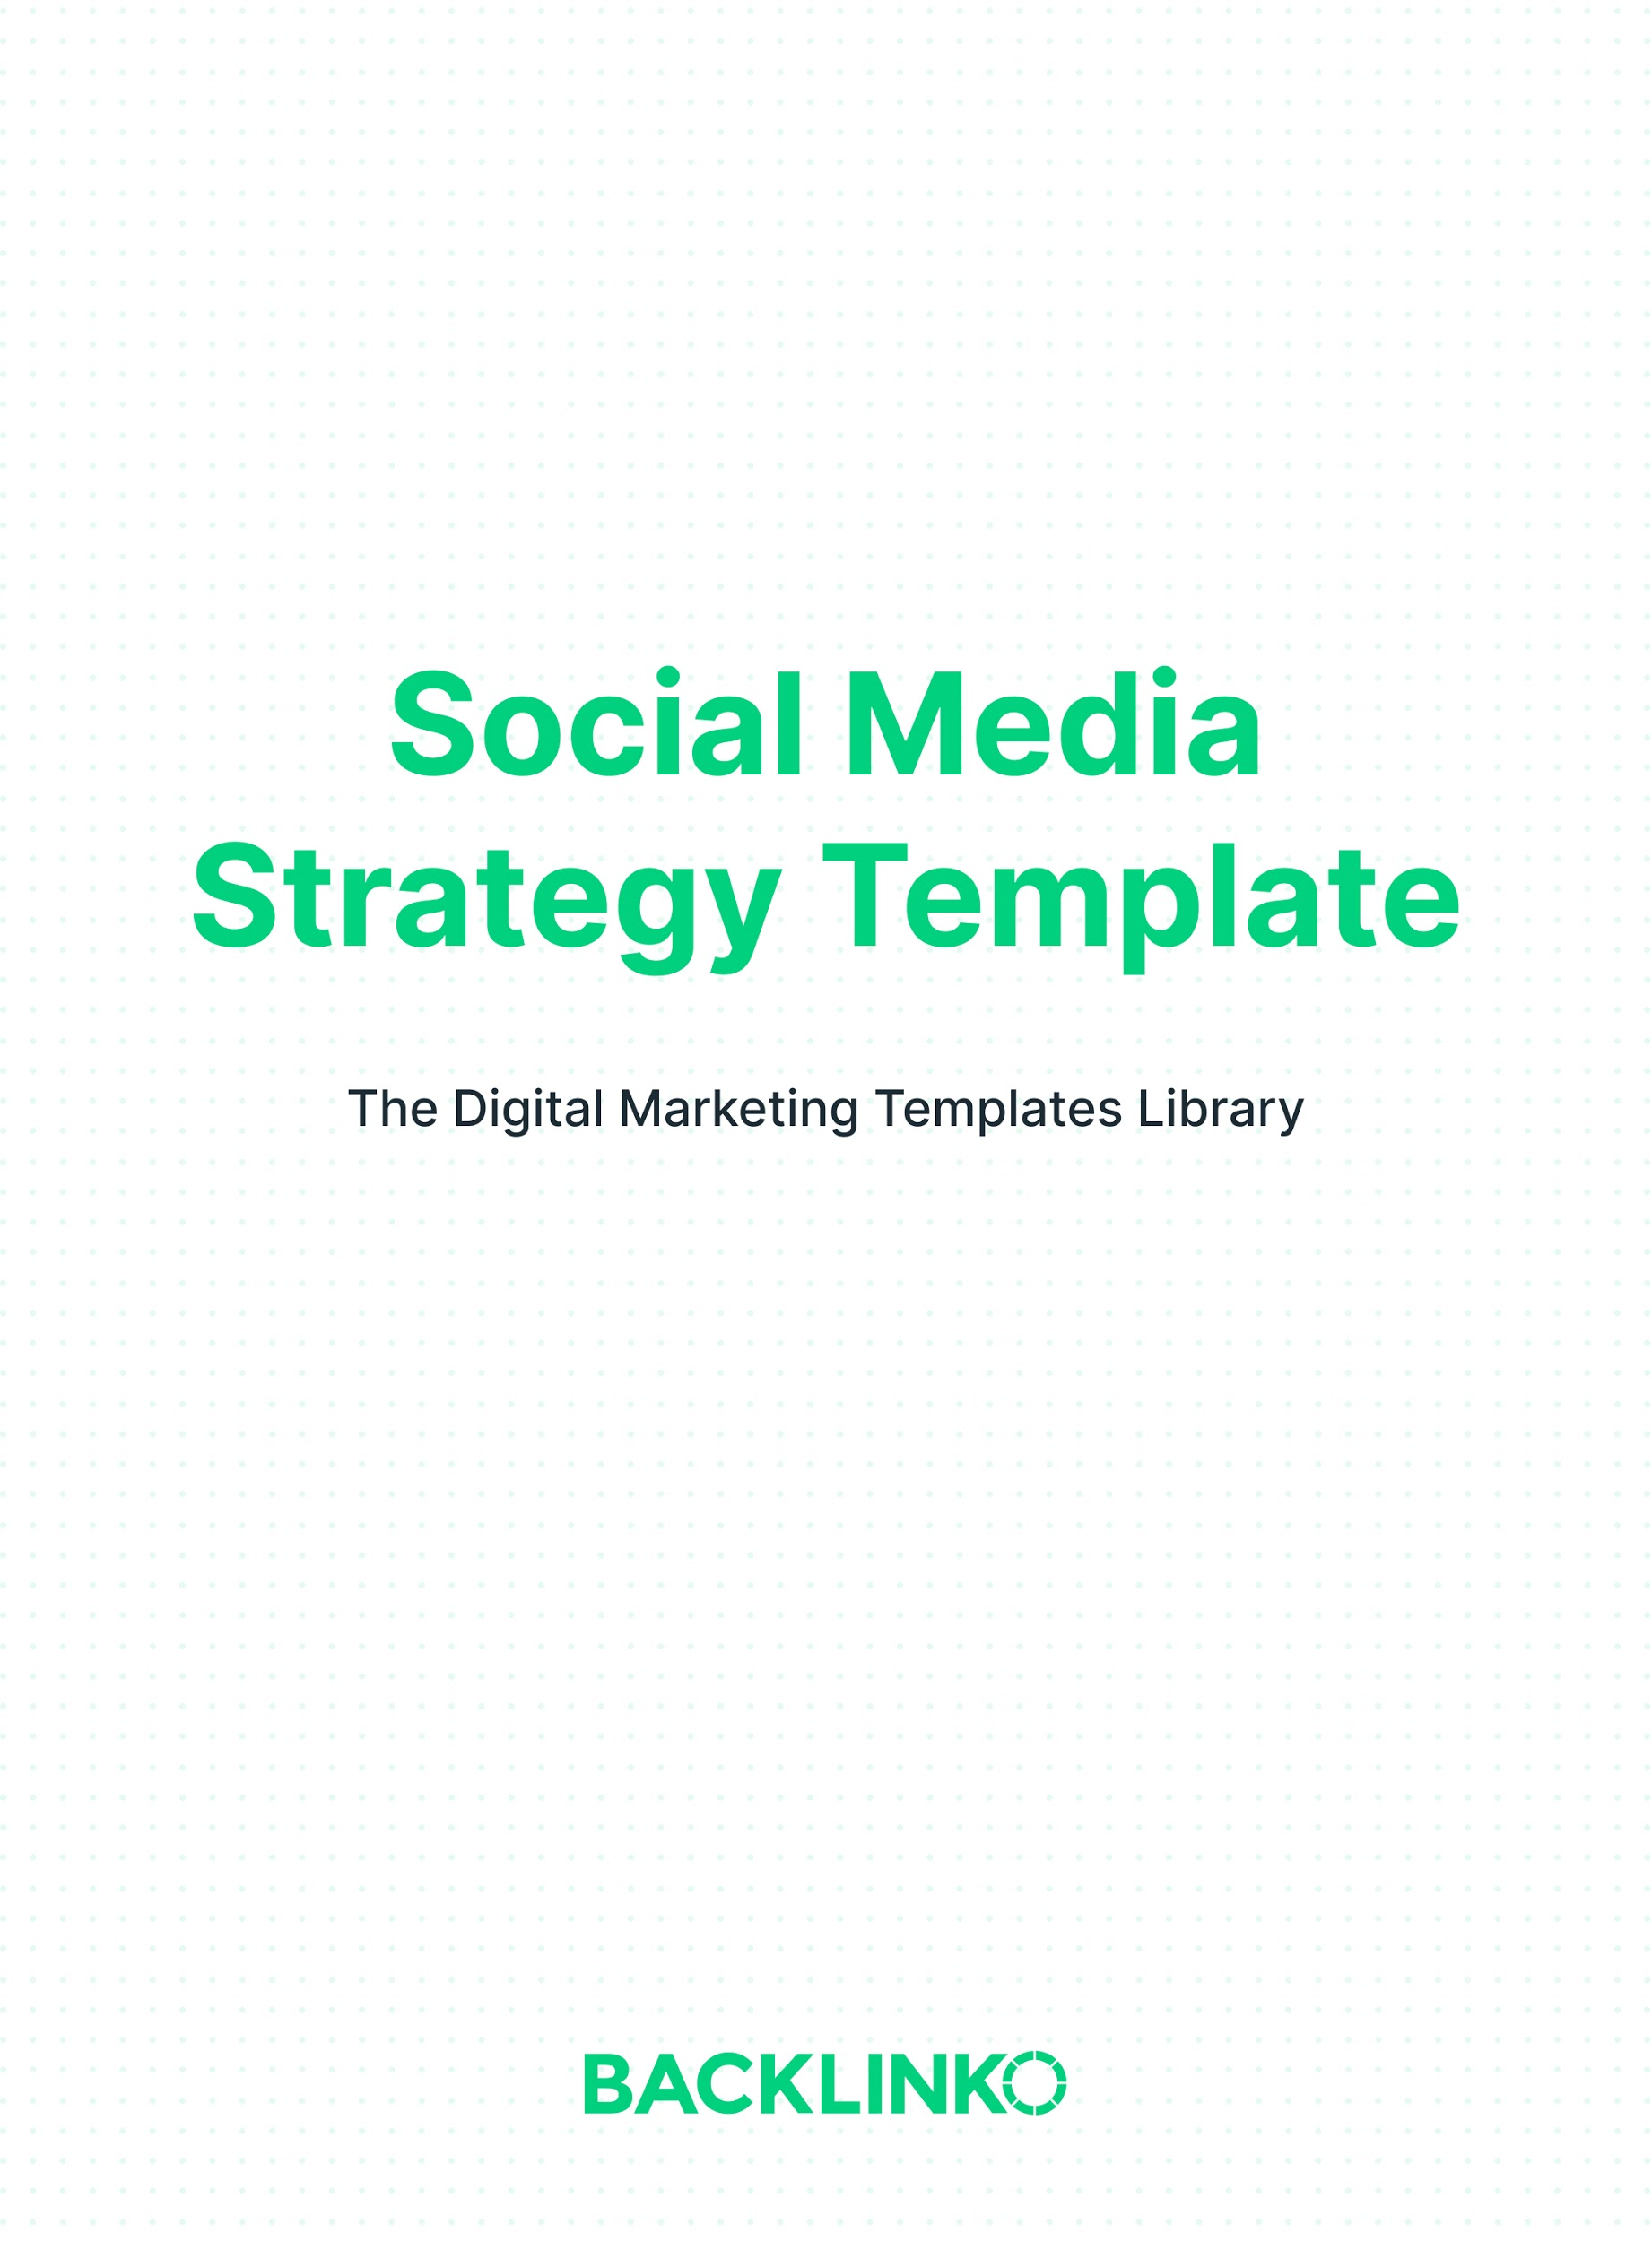

Social Media Goals and KPIs
For your social media strategy to be successful, you need to figure out what “success” looks like.

In this section, you’ll define the key performance indicators you will be focusing on and optimizing for.

I recommend using S.M.A.R.T. goals (Specific, Measurable, Achievable, Relevant and Time-bound). They make it easy to tell if you’re on the right track.

Goal | Social Media KPI | Details / Timeframe
E.g. Increase website traffic | E.g. Traffic from social networks | E.g. 50% growth YoY

Social Networks
There are over a dozen social networks that have 100+ million active users. Unless you have a massive team, you simply won’t be able to use all of them effectively.

In this section, you’ll choose which networks to prioritize (and which to ignore). Here’s how.

Find where your social traffic is already coming from
In Google Analytics, go to Acquisition ➡ All Traffic ➡ Channels, then click the “Social” channel grouping link in the report table below the chart. This will show you which social networks are already driving traffic to your website.

List your findings here:

Social Network | Monthly Traffic | Other KPI(s)
E.g. LinkedIn | E.g. 4,133 visits/mo. | E.g. 260 new email subscribers per month

Which social networks are getting engagement
Social media is good for more than just driving traffic directly to your site.

If you already have an active presence on social media, fill in the table below. Specifically, you want to estimate how much engagement you’re getting from your audience and potential customers.

Social Network | Follower Count | Engagement Level
E.g. Facebook | E.g. 23,749 | E.g. High

Competitive research
List your competitors’ top social networks below.

Here are two ways to find them:

- Look at the social traffic estimates shown in SimilarWeb for your competitors’ websites. (For example, here’s mine.)

- Look in the footer of your competitors’ homepages. There will usually be links to the social networks they’re most active on. And you can click through to see how much engagement they’re getting on each one.

Competitors’ top social networks:

Additional social networks
Now list additional social networks that you think your customers hang out on.

Top options to consider include Facebook, Instagram, Twitter, LinkedIn, YouTube, Reddit, Snapchat, Pinterest, Quora and TikTok.

(For reference, here is a longer list of the world’s most popular social networks, and here are some recent social media usage trends and statistics.)

In theory, every business has potential customers on every social network. But that doesn’t mean people will be willing to engage with your brand on all of them.

A great way to check if a particular social network is a good fit for your brand is to use its search function. Just search for relevant industry keywords. And your brand name and a few competitors’ brand names. The more discussion or engagement around those topics, the better.

Additional social networks:

Final list of social networks to use
Now, decide which social networks you’ll be active on. If you haven’t already done so, be sure to claim your brand username on each of these.

Social Network | Use? | Status
E.g. Twitter | E.g. Yes | E.g. Claimed @Backlinko, password saved in 1Password

Note: It’s also a good idea to claim your brand username on the major networks you WON’T be using (in case you decide to use them later. And also, to prevent imposters).

Engagement Plan
An engagement plan is one of the most important parts of a social media strategy. It outlines how you will use social media to reach and respond to your target audience.

Outbound: what to share, when and where
Use the table below to plan what types of content you’ll share, when you’ll share it, and which networks you’ll share it on.

For example, you may want to share:

- Your own on-site and off-site content (blog posts, podcast episodes, etc.)
- Original, native social content
- Other people’s content (your mentions in the press, content from thought leaders, industry news, re-sharing customers’ praise, etc.)

You may also find CoSchedule’s study on the best times to post on different social networks useful here.

What | When | Where
E.g. New Backlinko blog posts | E.g. When published; typically Thursdays at 8:30 am PST | E.g. Facebook, Twitter, LinkedIn

Inbound: social listening
While social media is a great content distribution channel, it can also be important for customer service, retention, and even sales.

The key here is responding quickly. Having this social listening action plan filled out ahead of time can help you do just that.

What will we listen for, and how will we respond?

Networks | Keywords, hashtags and usernames | When to listen | How to respond
E.g. Twitter, Facebook, Instagram | E.g. @Backlinko | E.g. M-F 8am-5pm PST | E.g. Thank for shares/compliments, answer questions. Try to respond to at least 10% of mentions.

Tip: Other than your own brand keywords, username and domain, you can also listen for common industry terms and competitors’ terms to find more opportunities to engage people.

Promotion
You can improve your reach quickly with some promotion.

There are paid and unpaid types of promotion, including:

- Paid boosts
- Retargeting
- Account takeovers
- Shout-for-shout

And more.

Use this section to plan potential ongoing and one-time social media promotions.

Promotion | When | Details
E.g. Facebook boosted posts | E.g. Every time we share a new Backlinko blog post | [Targeting, budget, etc.]

Tools
There are a variety of tools that can help you manage and optimize your social media activity, including Hootsuite, Buffer and Buzzsumo.

Use this section to plan which ones you’ll use.

Tool | Purpose | Cost
E.g. Hootsuite | E.g. Post scheduling, social listening, and analytics | E.g. $25/mo

And that’s it for my social media strategy template! I hope you found it useful.

Remember, you can find 20+ other marketing templates here.

Brian Dean
Founder, Backlinko.com

