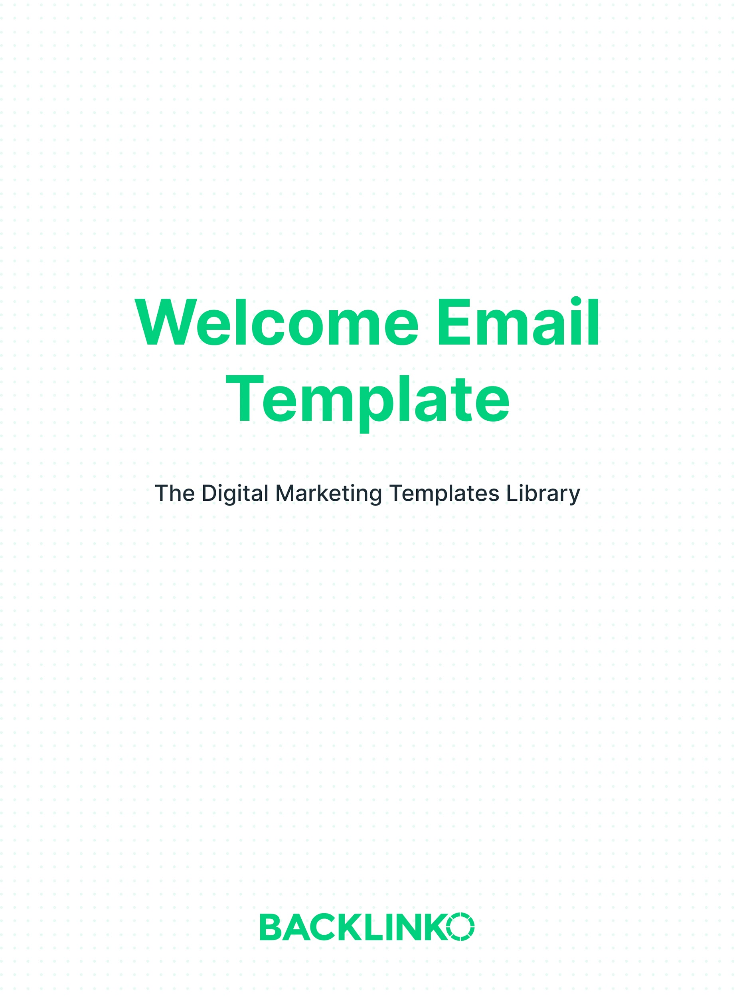

A great welcome email consists of 3 things:

- A warm welcome, which helps show people that signing up for your newsletter was a smart idea.

- What to expect from your newsletter.

- A call-to-action. For example, you can invite them to reply, follow you on social, or check out a piece of content.

You can see all of those in action in the following 2 examples:
Here’s the welcome email we use at Exploding Topics, which gets an impressive 75% open rate:

Subject:
You're in. Here's what's next

Body:
Hey,
You're the latest member of the Exploding Topics newsletter. Welcome!
Here's how it works:
1. Our advanced technology analyzes millions of searches, conversations and mentions across the internet.
2. Our algorithm identifies Exploding Topics… before they take off.
3. We curate the best topics from this list.
4. Each week we'll send you "Exploding Topics Tuesday": a curated list of the best trending topics that we find. Plus, insight and analysis.
You can read last week's newsletter to catch up on what you’ve missed.
See you on Tuesday.
Talk Soon,
Brian and Josh

And here’s a welcome email from The Hustle:

Subject:
Open for instruction

Body:
You’re in. Now what?

As you’ve probably noticed, you’re going to get an email each weekday at 8AM EST with our daily rundown of news, insights, podcasts, and (occasionally) our favorite Amazon pool floats.

*Extremely Infomercial Voice* But wait, there’s more!

If that doesn’t scratch your itch, we also do deep-dives every Sunday. We write ‘em, people love ‘em, it’s a whole big thing. Here are some fan faves:
- The restaurant owner who asked for 1-Star Yelp reviews
- The man who won the lottery 14 times
- How a janitor at Frito-Lay invented Flamin’ Hot Cheetos
- The rise and demise of the AAirpass, American Airlines’ $250k lifetime ticket
- The worst sales promotion in history

Still haven’t gotten your fix?

We have a free book you can get when you share The Hustle with 3 friends (click "Share The Hustle" below).

Need social? We have it. We’re active on Instagram, Facebook, and Twitter. Toss us a like -- it’s the least you could do.

Happy reading,
-Us’tle at The Hustle

Now, here’s your welcome email template:

Subject line:
[Short teaser of what’s inside]

Body:
Hey [their first name if you have it],

[Warm welcome, which helps show people that signing up for your newsletter was a smart idea.]

[What to expect from you and your newsletter.]

[Call-to-action.]

[Signature]

And that concludes this template. You can find 20+ other marketing templates (including more email marketing templates) right here.

Brian Dean
Founder, Backlinko.com

