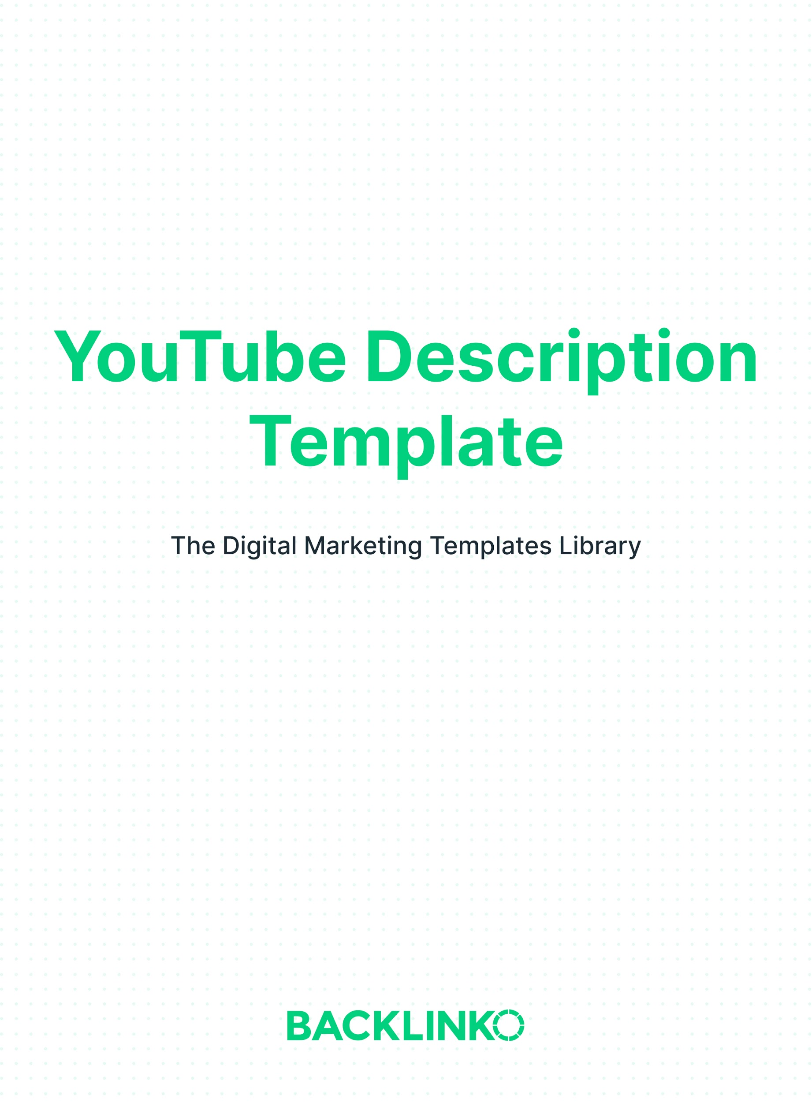

Here are 3 quick tips to make a great YouTube description:

- Write a detailed description, with your target keyword repeated 2-3 times. Try to write a 200+ word description for each video. This will give YouTube a deeper understanding of your video’s topic. Which will help your video show up as a suggested video, bringing in more viewers. And including your target keyword multiple times will help emphasize what your video is about.
- Focus on the first 2-3 sentences. YouTube’s algorithm puts more weight on the keywords that show up in the first 2-3 sentences of your description. In fact, YouTube directly recommends that you “put the most important keywords toward the beginning of your description”. So include your main keyword (and other important keywords) early on in your description.

- Optimize it for CTR. The first couple sentences of your description will appear in the search results. So it’s important to make this snippet SEO-friendly and compelling to click on. Otherwise, people may scroll right past your video in the search results. I like to start my descriptions off with the benefit someone will get from watching the video.

I try to do all 3 of those things for all of my videos. You can see them all in action in the description from my video: How to Start (And Grow) a YouTube Channel in 2020.

Also, make sure to use an original description for each video. (The phrasing can be similar, but don’t keep re-using the same exact text.)

Now, here’s your YouTube description template.

Replace the example text with your own.

(Note: All of this text should go into the same video description field. The separate sections here are just to help show the different parts to pay attention to.)

Compelling Introductory Snippet:

In this video you’re going to learn exactly how to start (and grow) a successful YouTube channel this year.

To be clear: growing a YouTube channel takes hard work. But with this video tutorial, you’ll have a proven process that you can use to get more views and more subscribers.

Detailed Video Description

With that, here’s what I’m going to cover in this video.

#1: First, I’ll show you how to set up your channel for success on day 1. So whether you’re new to YouTube or want to improve your existing channel, these tips on setting up your channel icon, channel art and playlists will come in handy.

#2: You’ll learn how to find keywords (and topics ideas) for your videos. SEO is a big part of getting views on YouTube. And I show you exactly how to find popular keywords to optimize your videos around.

#3: Learn exactly how to optimize your videos for SEO, step-by-step. Here’s where you learn how (and where) to add keywords to your video title, description and tags.

#4: Now that you’re getting views on your videos, it’s time to turn those views into subscribers. I show you how to get more YouTube subscribers by creating engaging videos that get high levels of Watch Time and Audience Retention.

All in all, you have a game plan for starting a YouTube channel (and growing it).

Call to Action

SUBSCRIBE to get higher rankings and more traffic!
http://www.youtube.com/subscription_center?add_user=backlinko

Links to Your Website and/or Social Media

Follow me on Twitter!
https://twitter.com/Backlinko

I hope you liked this YouTube description template. Remember, you can find 20+ other free marketing templates right here.

And for more YouTube and SEO marketing tips, be sure to follow me on YouTube.

Brian Dean
Founder, Backlinko.com

