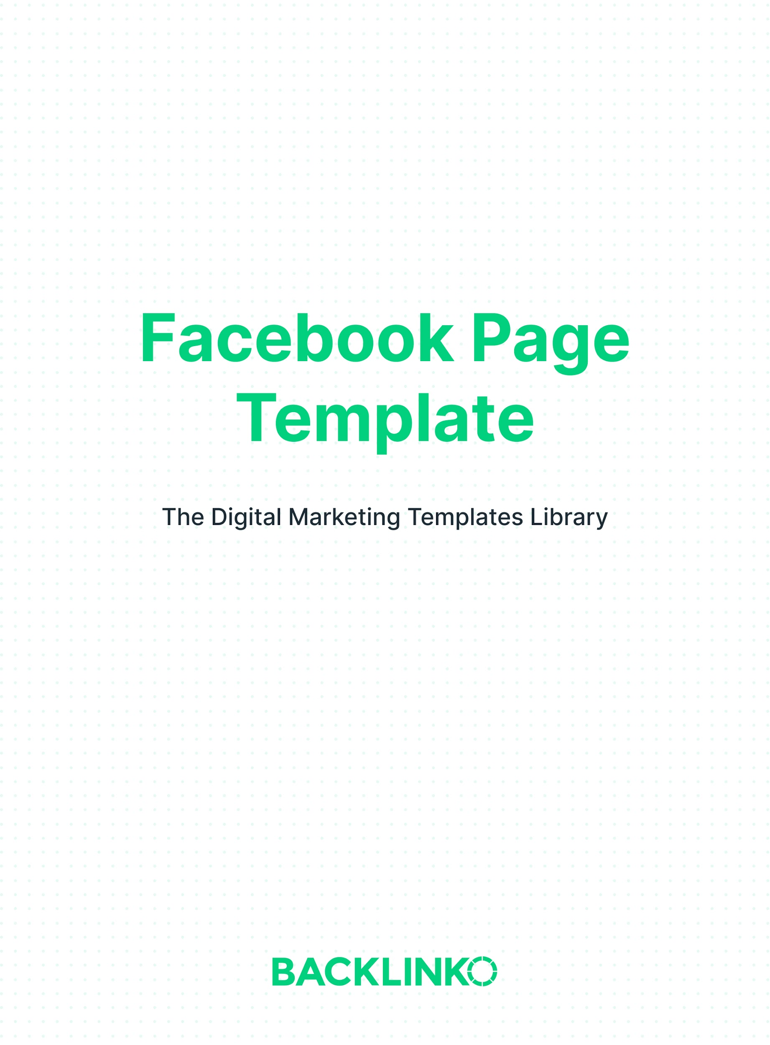

Business Information

Page Name
Your Page name gets displayed at the top left of your Page. Facebook doesn’t allow descriptions or slogans in Page names. So there isn’t a lot of room for creativity here.

Instead, it’s generally best to name your Page after your business.

For example, the name of the Backlinko Facebook Page is simply “Backlinko”. (Not “Backlinko: the best SEO training on the planet”.)

You can see Facebook’s other rules on naming Pages here.

Write your Page name below:
E.g. Backlinko

Description
Your Page’s description is just what it sounds like: a description of your business. You can use it to tell people about your products and services, which can help your business be discovered more often.

Note: there is a 255 character limit.

Write your Page description below:
E.g. Backlinko is an SEO training business that helps search engine marketing professionals get better results. Learn more at: http://backlinko.com

Category
Categories help Facebook understand what your Page is about. Using relevant categories will make your Page more visible to users.

There’s a huge variety, so we won’t list them all here. But you can select up to 3 from the options in your Page settings.

Page Username
Your Page’s username determines your Page’s custom URL. For example, Backlinko’s Page username is “Backlinko”. Which gives us the URL: facebook.com/Backlinko

The Page username is separate from the Page name, which you filled in before. But you can use the same thing for both as long as it’s not taken.

There are a few rules about what usernames are allowed. For example:

- It has to be a minimum length of 5 characters
- It can’t contain generic terms or domain extensions such as .com
- It can’t have any spaces

What will your Page username be?
E.g. Backlinko

Profile Picture and Cover Photo
Choose images that represent your business well. Facebook lets you add 2 images to your Page: a profile picture and a cover photo.

Profile picture
A square image. Recommended size: 180x180px. Most businesses use their logo or the owner's face. Note: this image will be cropped to a circle.

Cover photo
A larger image displayed at the top of your Page. Recommended size: 820x360px. Try using a picture of your product, storefront, sign, staff, or a custom graphic that explains what you do. Note: the sides of this image will be cropped on mobile screens.

(If you’re curious, here’s what Facebook says about how these are displayed on different devices.)

Tip: if you need to have an image made, 99Designs is my favorite place to find designers.

What images will you use?

Profile picture | Cover photo
E.g. Company logo | E.g. Storefront photo

Call-to-Action Button
You can add a call-to-action button that directs visitors to do something. (Like follow your Page or visit your website.)
The call-to-action button is displayed under your cover photo.

Facebook offers 15 different options, ranging from “Follow” to “Send Message” to “Learn More” and “Shop Now”. Choose the one that best fits your business.

About Tab
The “About” section includes information like:
- A link to your website
- Business hours
- Contact information

You can also add more detailed location info, service areas, and even your business’s Wi-Fi network info. Generally, the more info the better. But it’s your call.

And that’s our Facebook Page template. I hope you enjoyed it! Remember, you can find 20+ other free marketing templates right here.

Brian Dean
Founder, Backlinko.com

