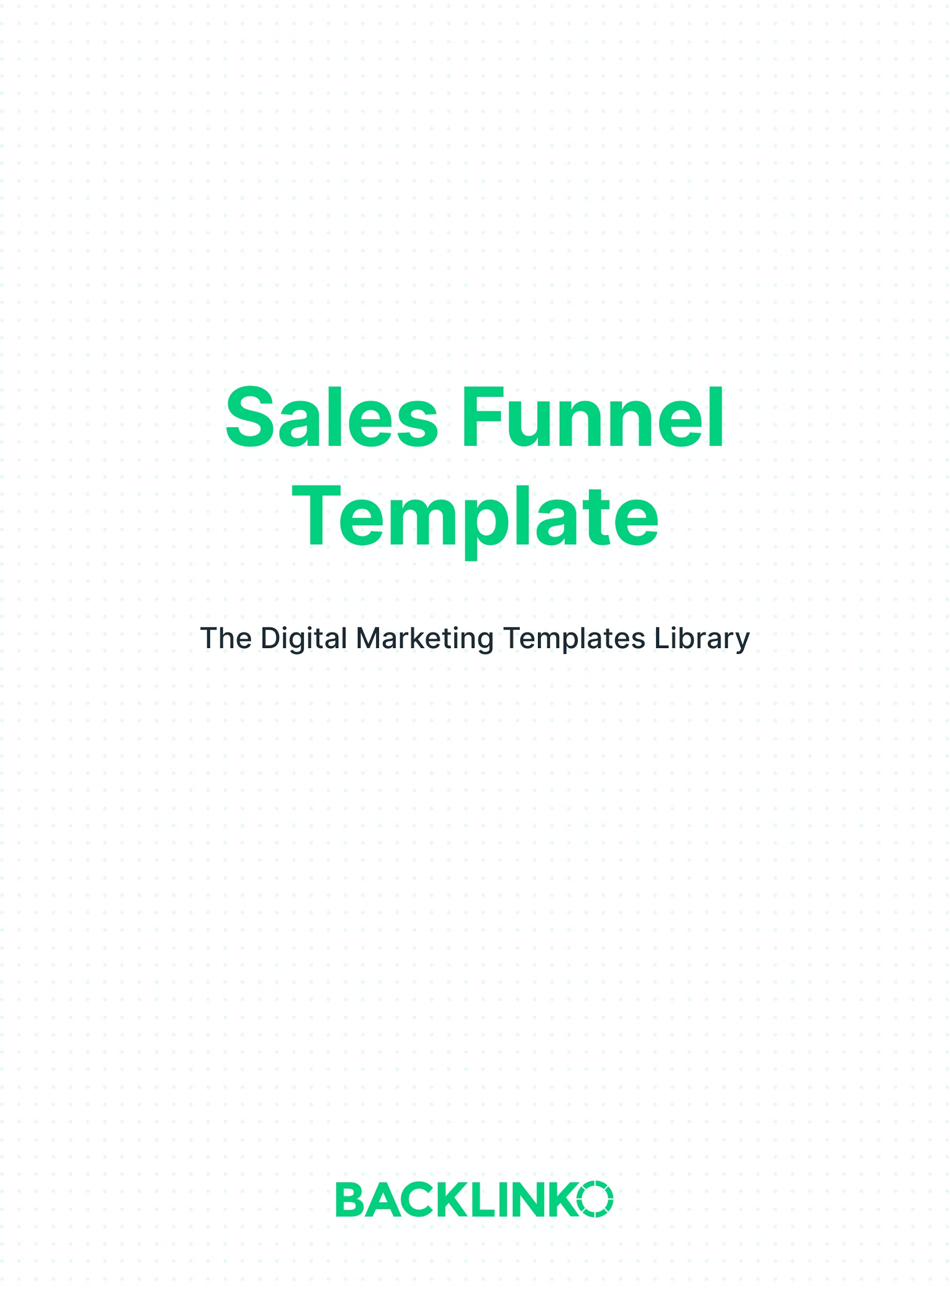In this template, we’ll cover the 3 major levels of an effective sales funnel.

In reality, a sales funnel can have any number of steps. Your business may call for an 8-step funnel. Sometimes the steps overlap as well.

And of course, a business or product can have more than one sales funnel.

This template isn’t meant to limit your options. But rather, think of it as a basic outline to the key components of EVERY sales funnel. And adjust the details as needed.

Now, here’s your sales funnel template.

Fill in the boxes under each section to create your own plan.

Top of the Funnel:
The top of your sales funnel is where you’ll get most of your traffic. Top-of-funnel traffic tends to be high in volume, but low in conversion rate.

In other words, most of your top-of-funnel traffic isn’t ready to buy yet.

In Backlinko’s case, SEO is by far our most important top-of-funnel traffic source. 80% of our visitors come from search traffic to the Backlinko blog.

But we also get top-of-funnel traffic from:

- Our YouTube videos.
- Other social networks like LinkedIn, Twitter and Facebook.
- And coverage from the press or marketing industry sites.

Traditional advertising channels like TV, radio and billboards are also top-of-funnel traffic sources. So are most banner ads, YouTube ads and Facebook ads. (Though it depends on how they’re targeted.)

The goal of the top of your funnel is to convert first-time visitors into leads. In other words, to move them from the top of your funnel to the middle of your funnel. One of the best ways is to offer a lead magnet to people who subscribe to your email newsletter.

For example: a downloadable content upgrade, access to gated content, or a discount code if you’re in ecommerce.

Where will you get your top-of-funnel traffic?
E.g. SEO, Facebook and Instagram

How will you convert your top-of-funnel traffic into middle-of-funnel traffic?
E.g. Email pop-ups with content upgrades

Middle of the Funnel:
The middle of your sales funnel is where people start to engage more with your brand. It’s where you can warm up cold leads. And build trust.

This can be as simple as re-engaging people with new content regularly. Or as strategic as a well-planned lead-nurturing sequence. Either way, your goal in the middle of the funnel is to prime your auBefore finally moving them to the bottom of your funnel.dience so they’ll be more likely to buy later.

Here are a few examples of middle-of-the-funnel traffic:

- Your email list.
- Search keywords with medium commercial intent. (Whether you capture search traffic with SEO or PPC.)
- Your social media followers.

Where will you get your middle-of-funnel traffic?
E.g. Email list and Instagram followers

How will you build trust in the middle of your funnel so that people will want to buy from you later?
E.g. I’ll email every new blog post to my list, with a short introduction

Bottom of the Funnel:
The bottom of your sales funnel is where you’ll finally SELL to people.

Most people will never make it to the bottom of your funnel. But the ones who do are very warm leads. So make your offer and don’t be shy.

Bottom-of-funnel traffic often includes:

- Search keywords with HIGH commercial intent. Like “buy” keywords. (Which again, you could target with either SEO or PPC.
- Email sales sequences.
- Visitors to your sales or product pages. (Who you can retarget, by the way.)
- Webinar attendees.
- People who submit a lead form on your website.
- Word-of-mouth referrals from existing customers.

Where will you get your bottom-of-funnel traffic?
E.g. Retargeting ads, free webinars with discount offer at the end

What product or service will you offer, and how will you pitch it? (Tip: for help writing sales copy, see our copywriting guide.)
E.g. Dog training video course sold via a long-form sales page

I hope you enjoyed this sales funnel template. And remember, you can find 20+ other marketing templates right here.

Brian Dean
Founder, Backlinko.com

